**E-BUYan: WEB-BASED E-COMMERCE OF TUY PUBLIC MARKET AMIDST COVID-19**

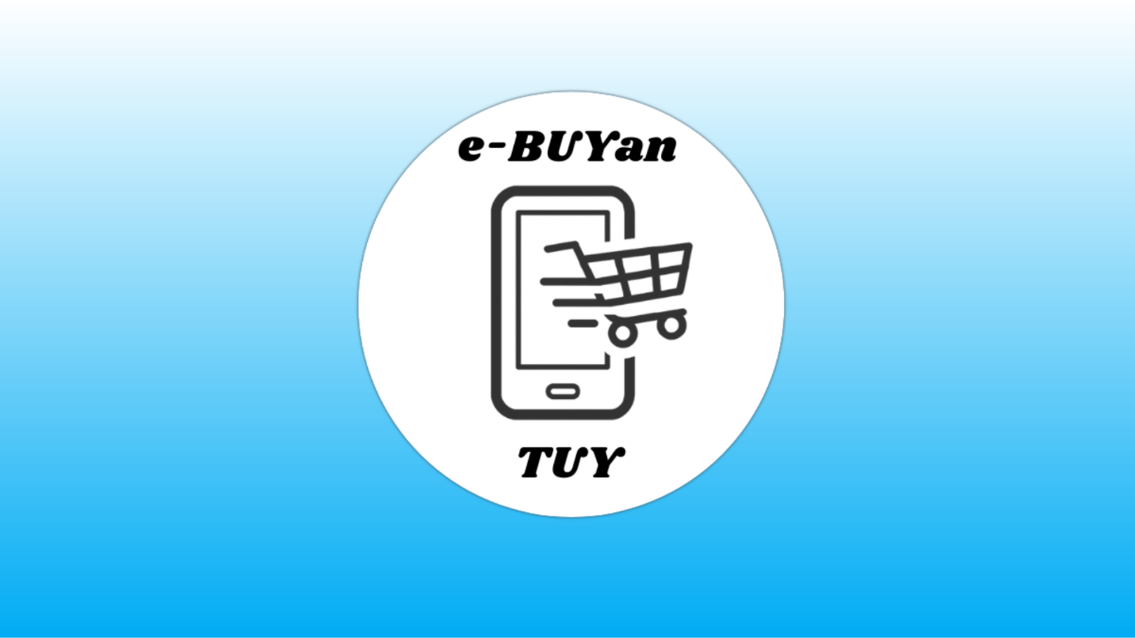

## **User Log In**

The first module that the user will encounter is the user log in where the user will input the username and password. Four different accounts can log in into the system. Admin, Vendor/Store Owners, Customers and Drivers.

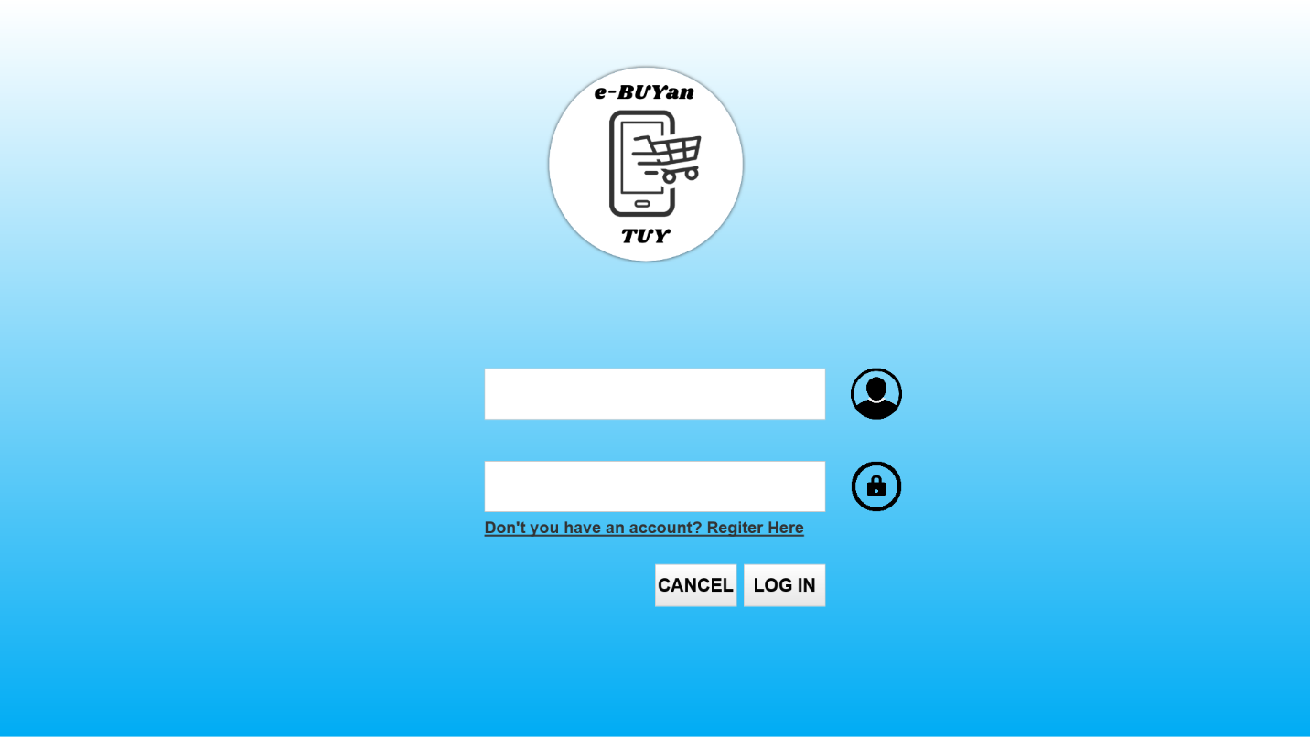

## **Account Registration**

There are three account types that users can register. Vendor/Store Owner, Customer and Driver. Account types have different information requirements. Once an account has registered, the user can continue to perform tasks in the system.

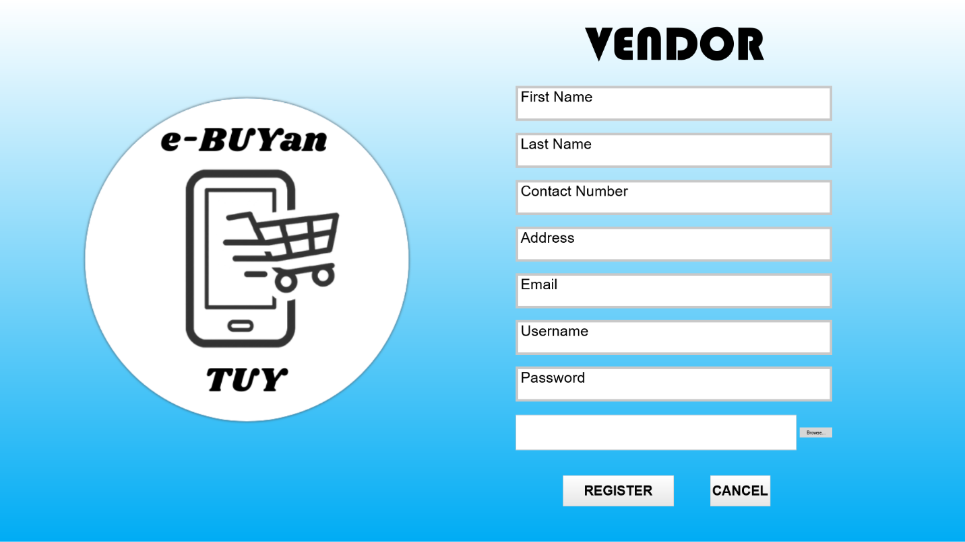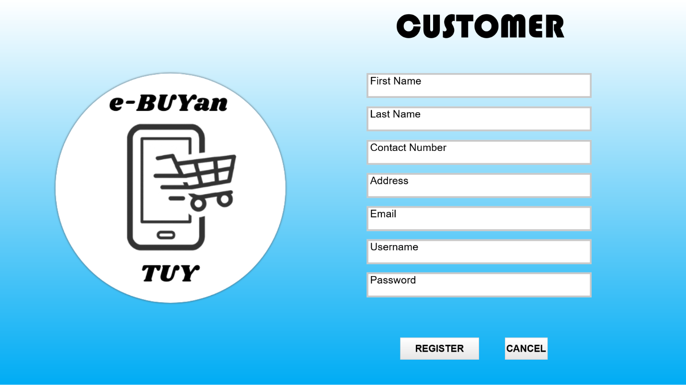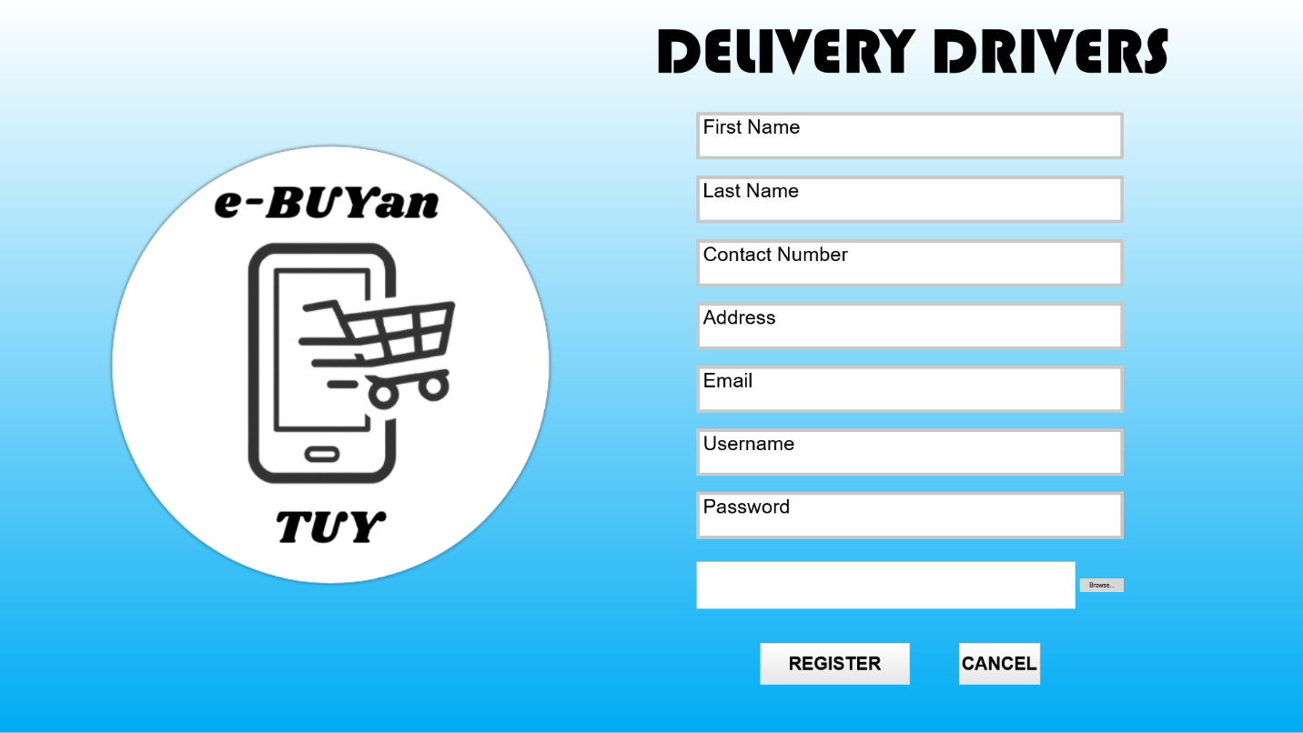

## **Admin Panel**

If an admin account is identified in the log in module, it will be redirected into the Admin Panel, in which a summary of accounts types can be seen and the navigation of the admin modules.

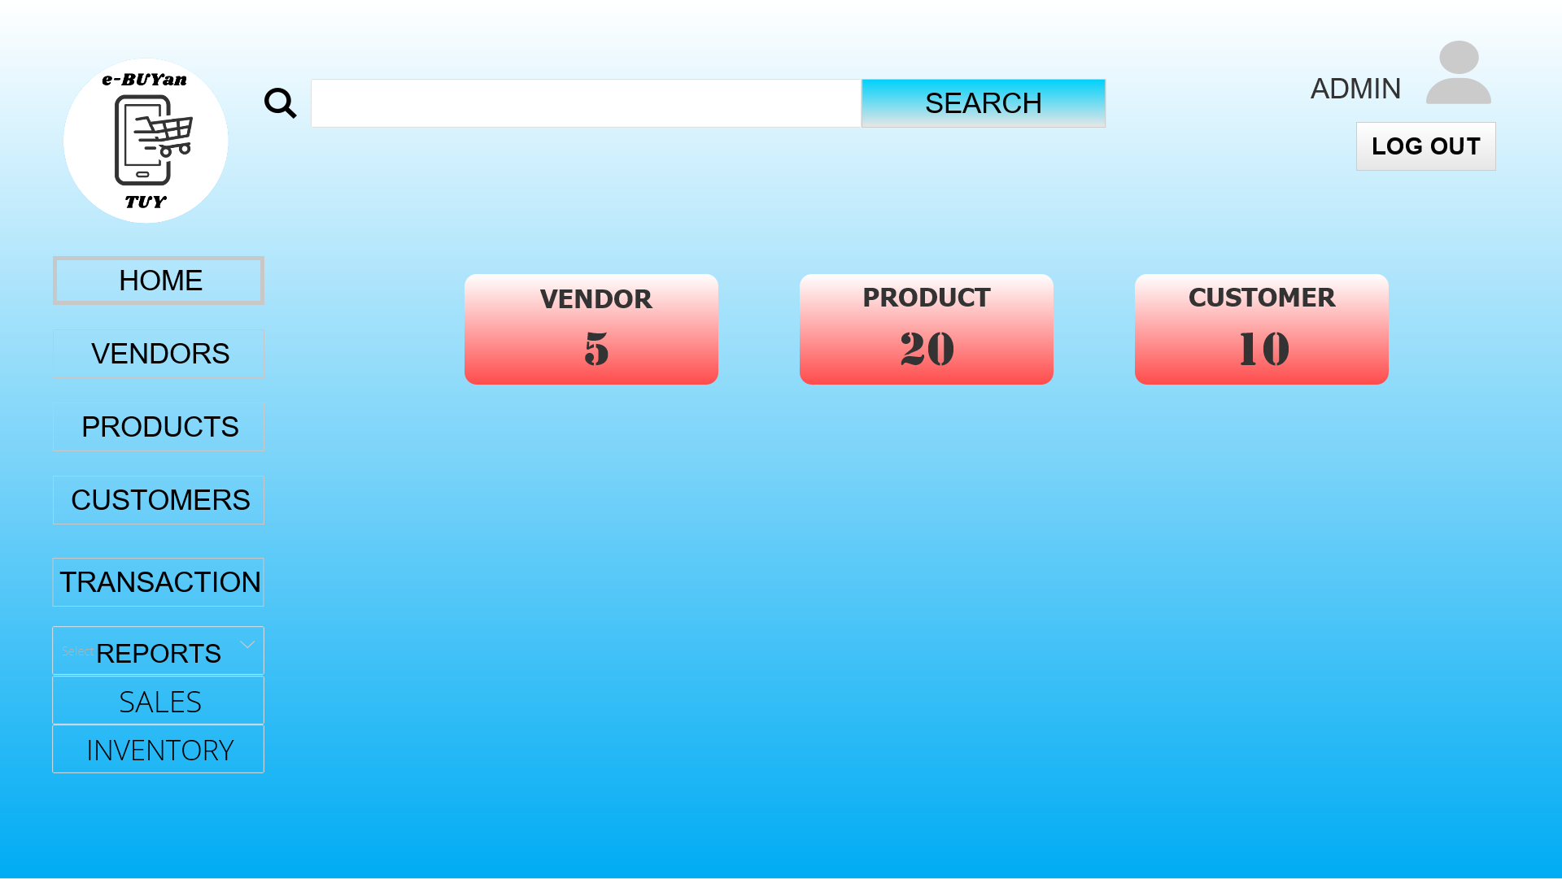

## 

## **Admin Profile**

In the admin profile. The admin can update profile credentials such as username, password and display photo.

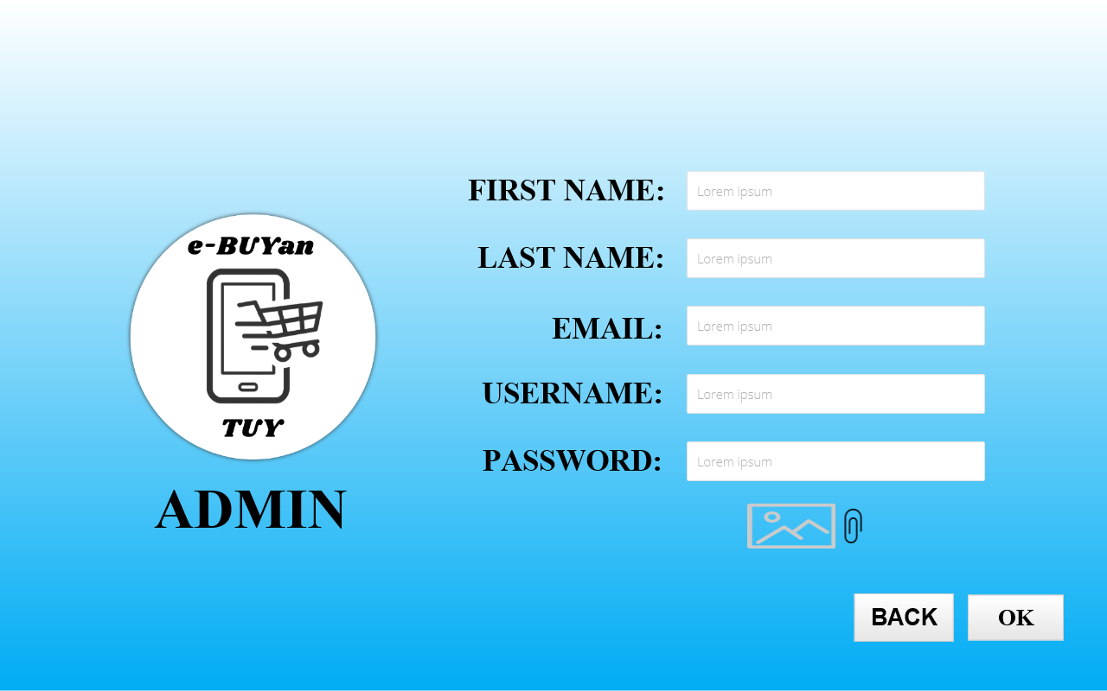

## **List of Vendors**

In the list of vendors, the number of registered vendors can be seen. The admin can view the details and delete the vendor account.

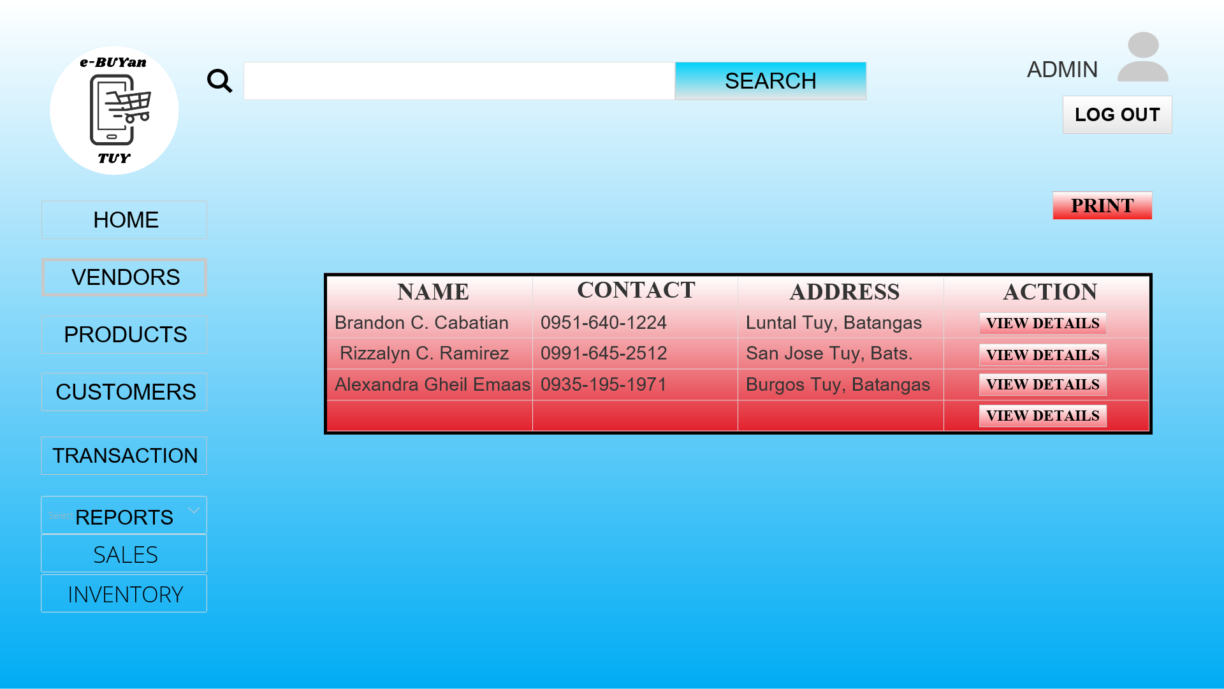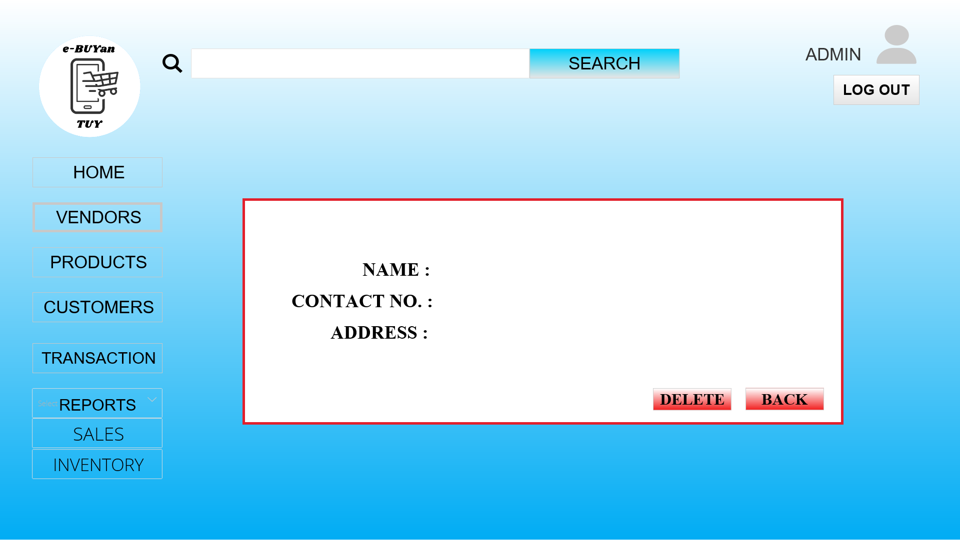

**List of Products**

In the list of products, the products in the system are displayed and can view the details as well as deletion if the products reached certain parameter.

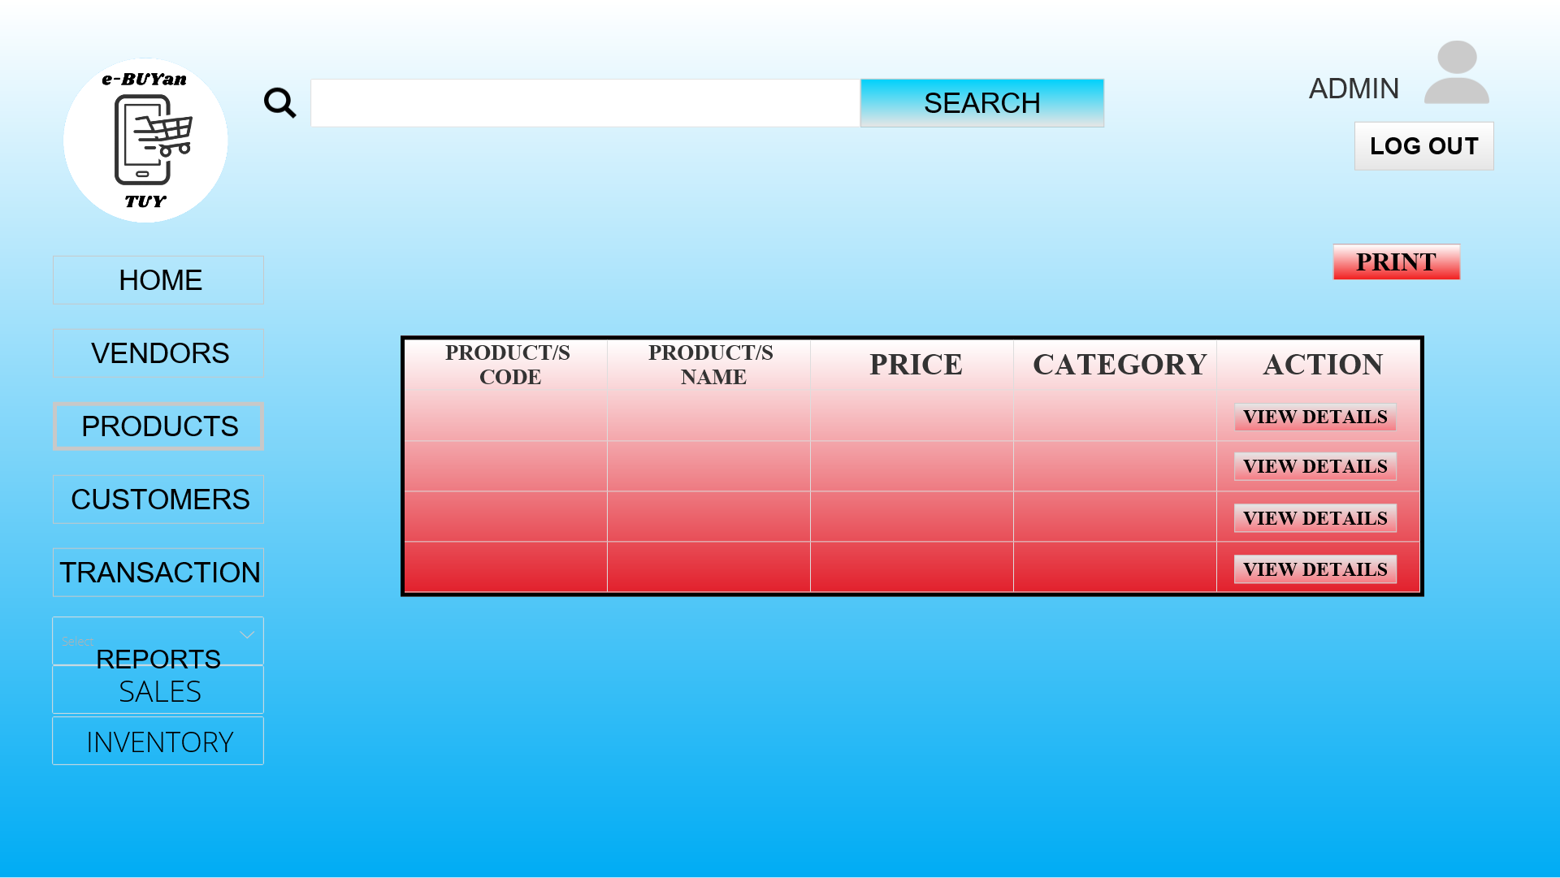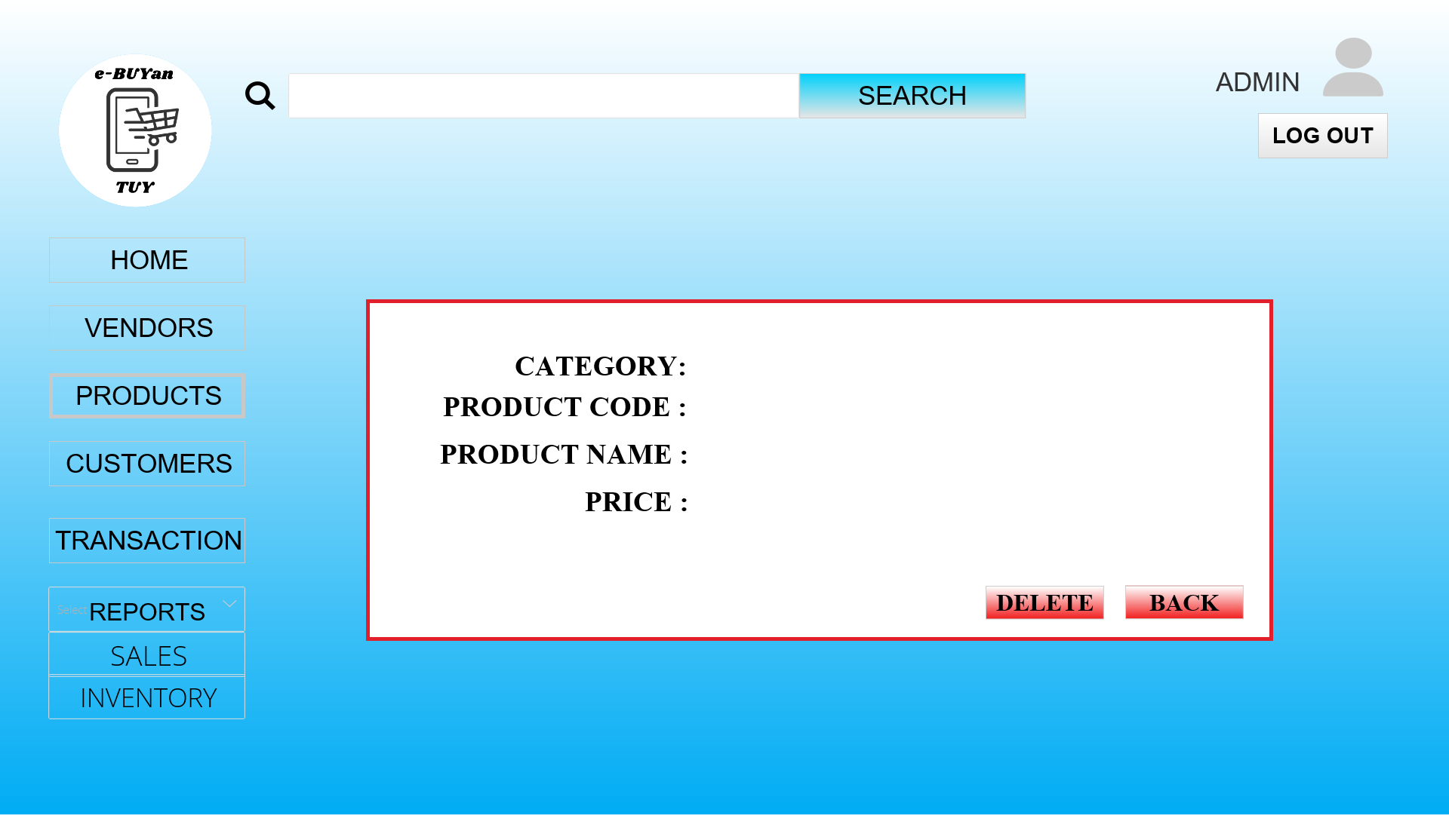



## **List of Customers**

The admin has the list of the registered customer accounts. The admin can view details of the customer and can delete the account if the violated certain rules.

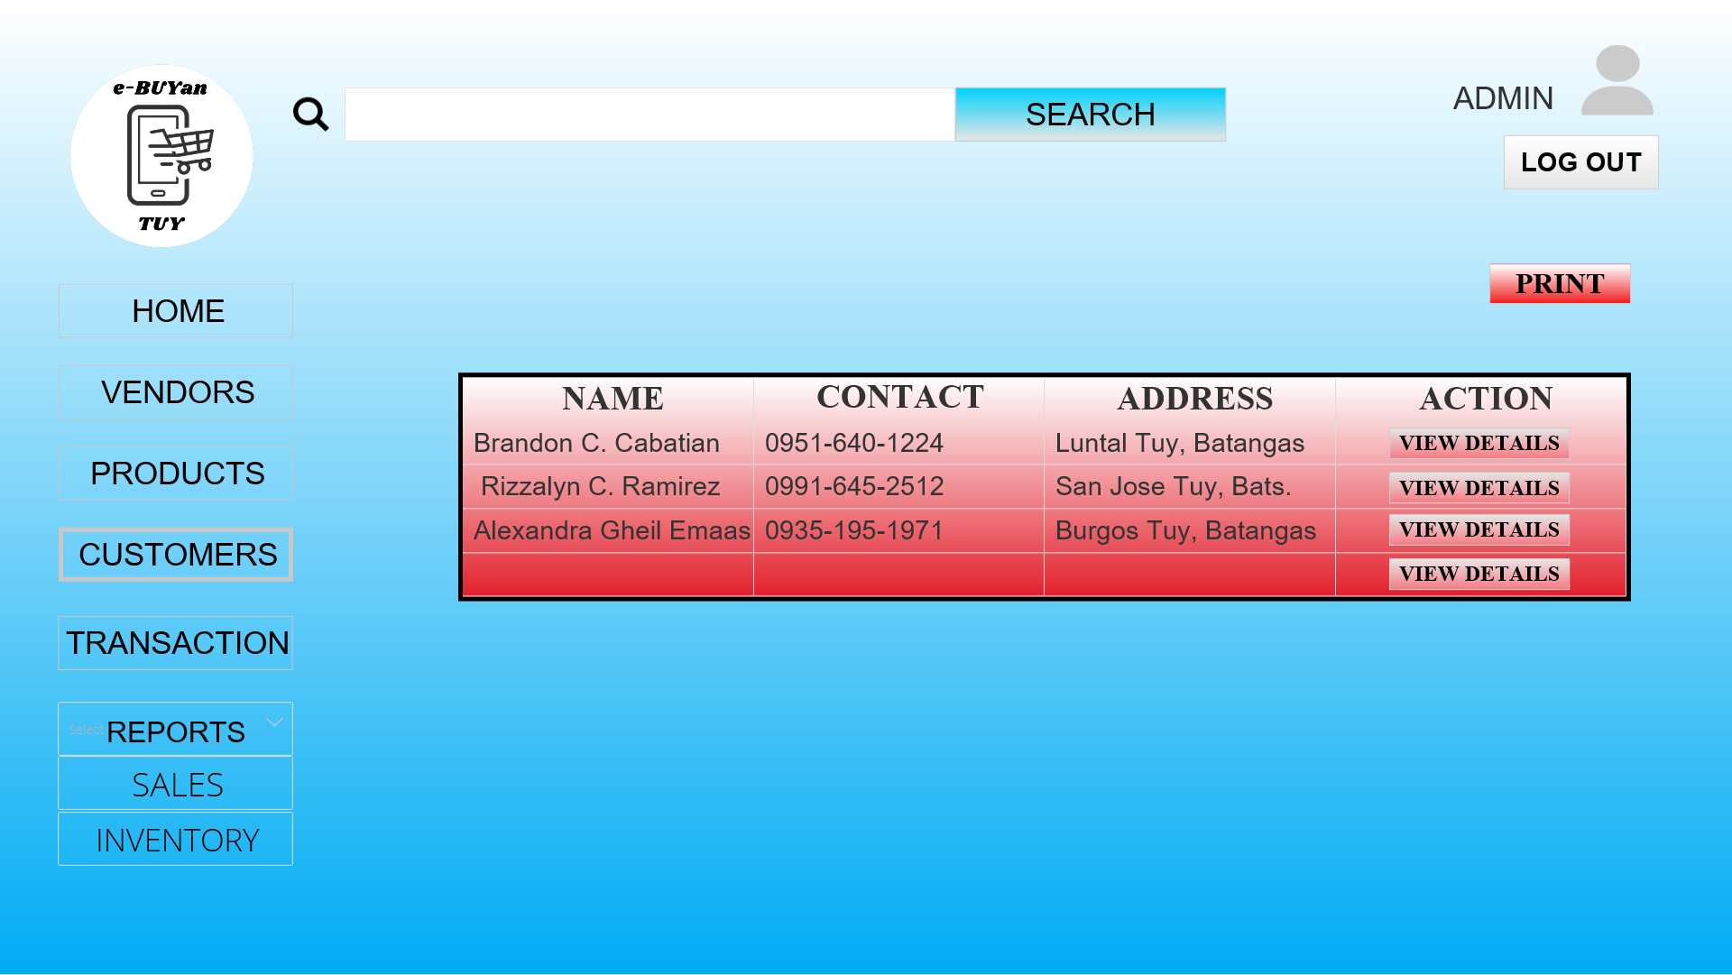

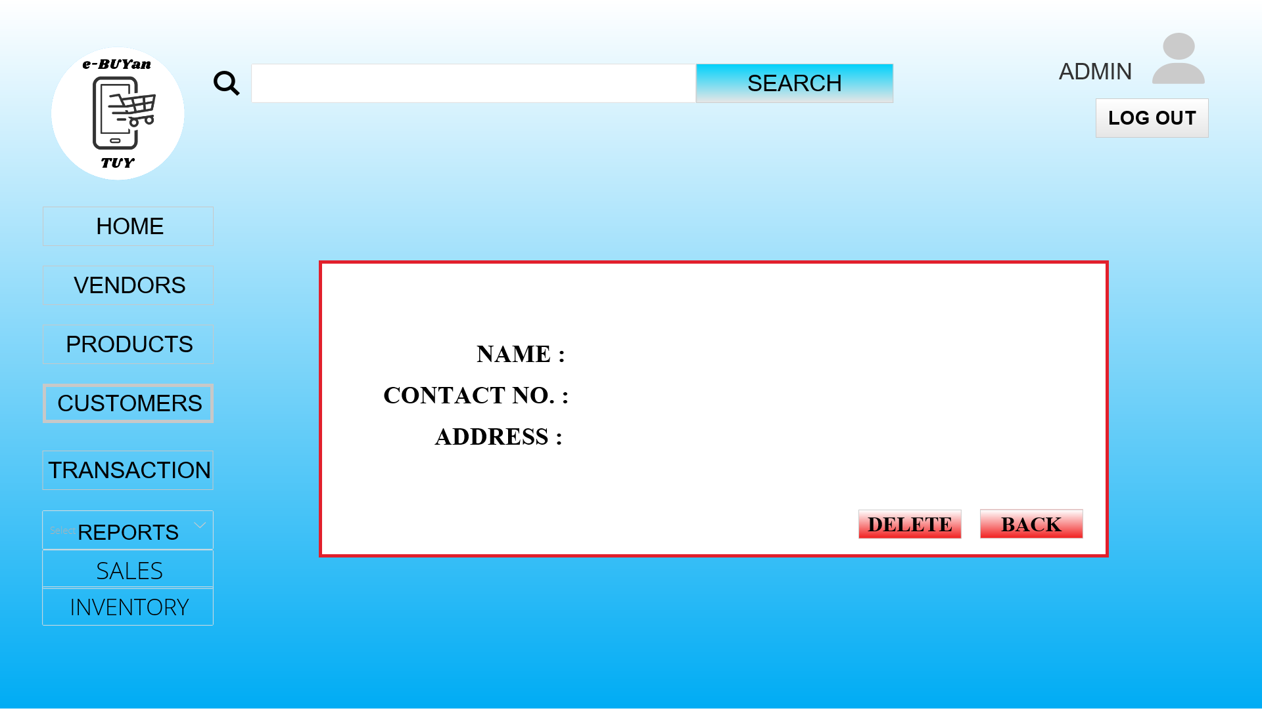

## **Transactions**

The admin has the records of the transactions made in the system.

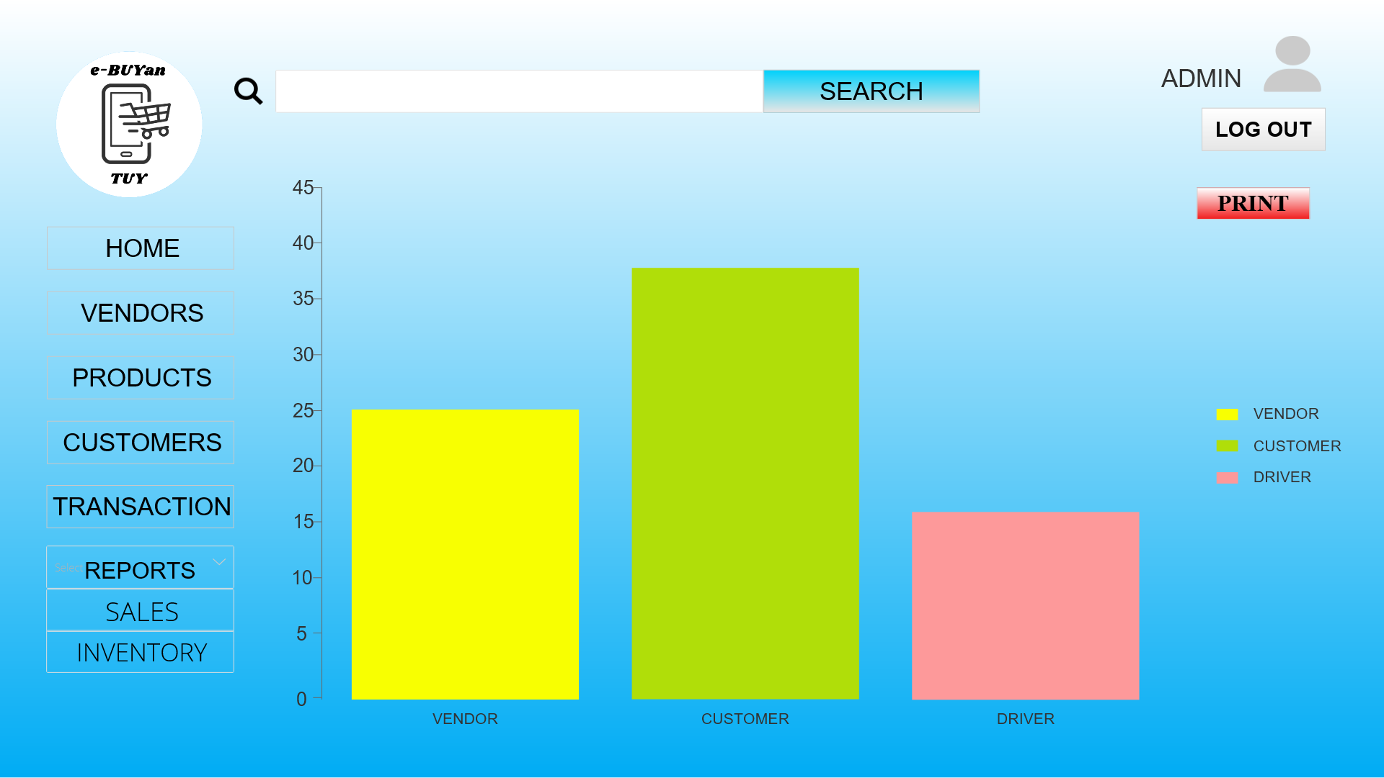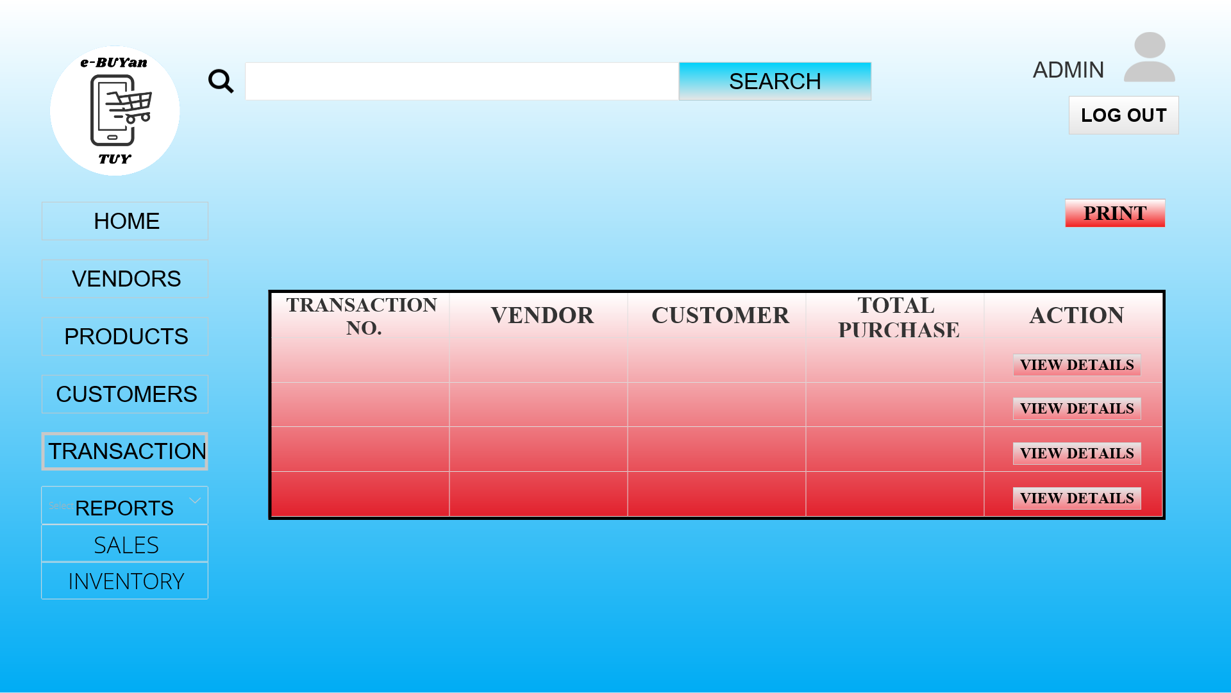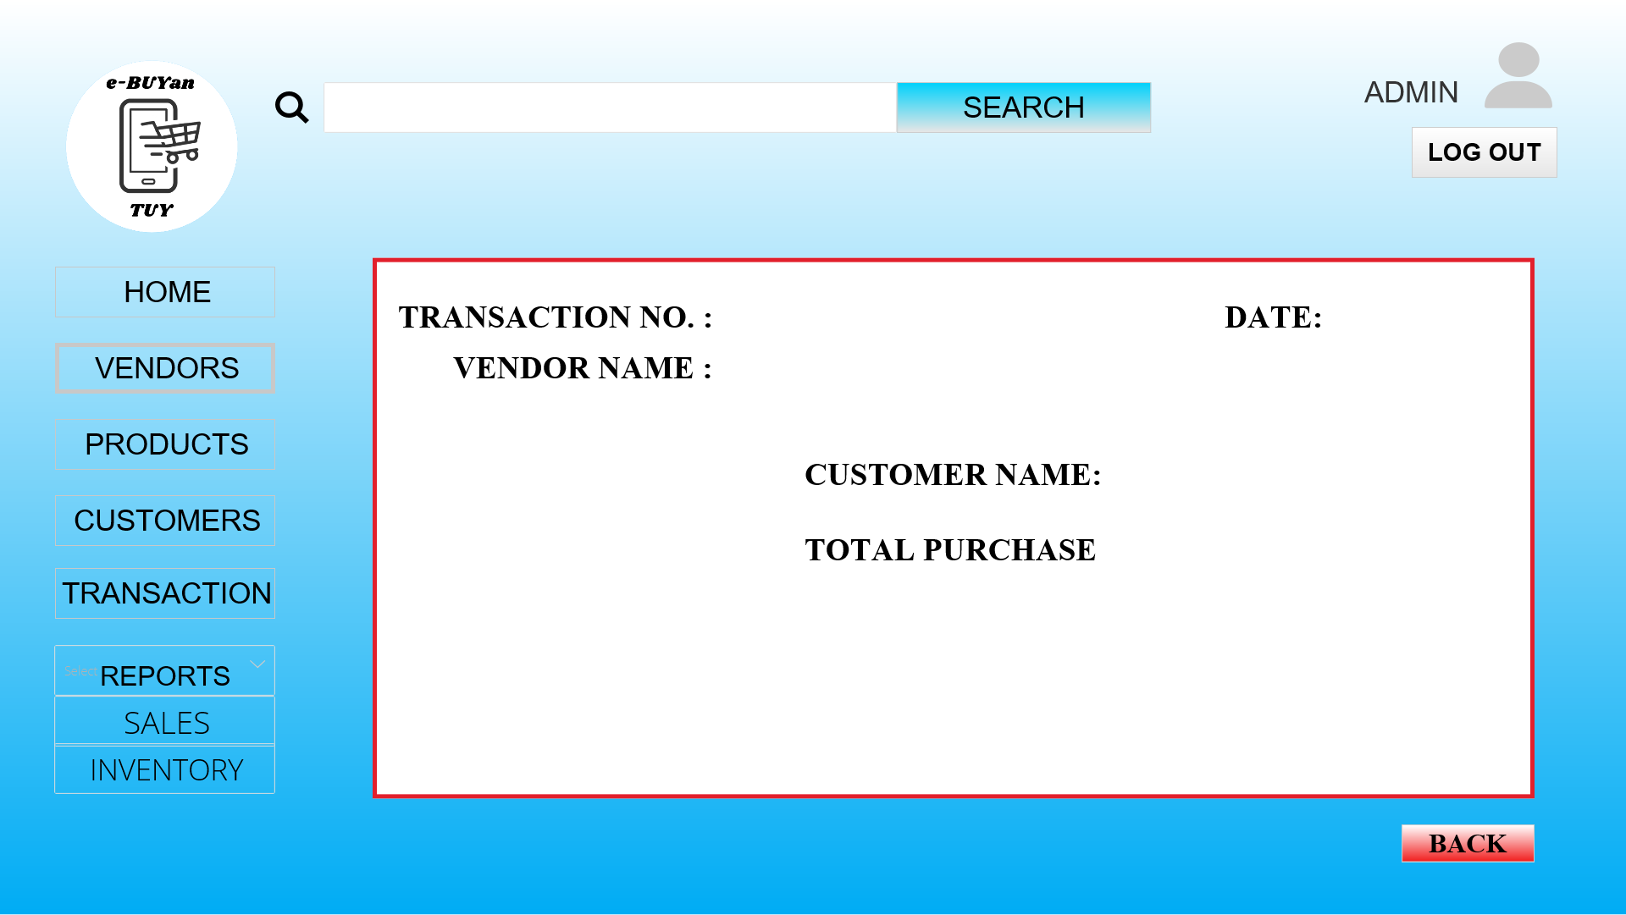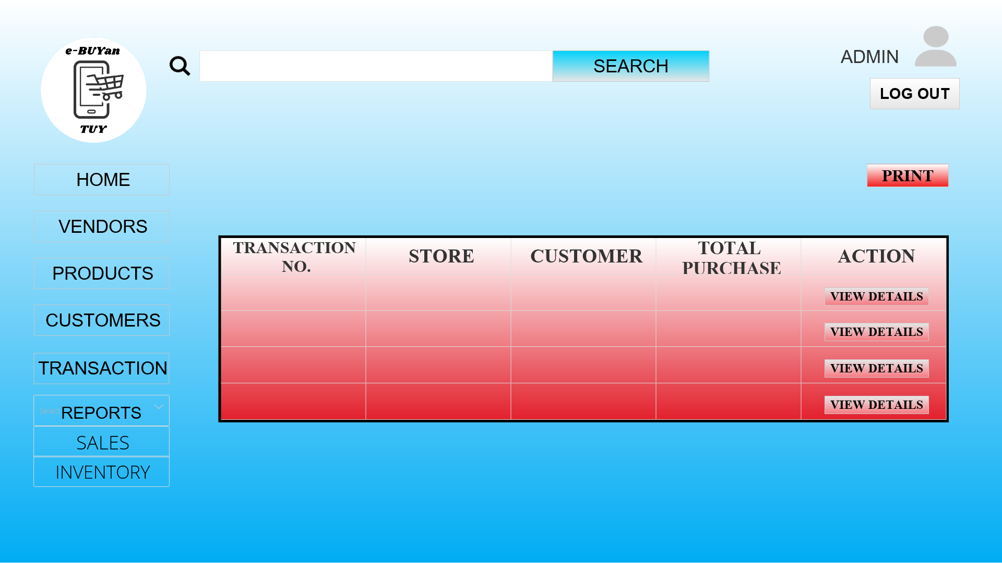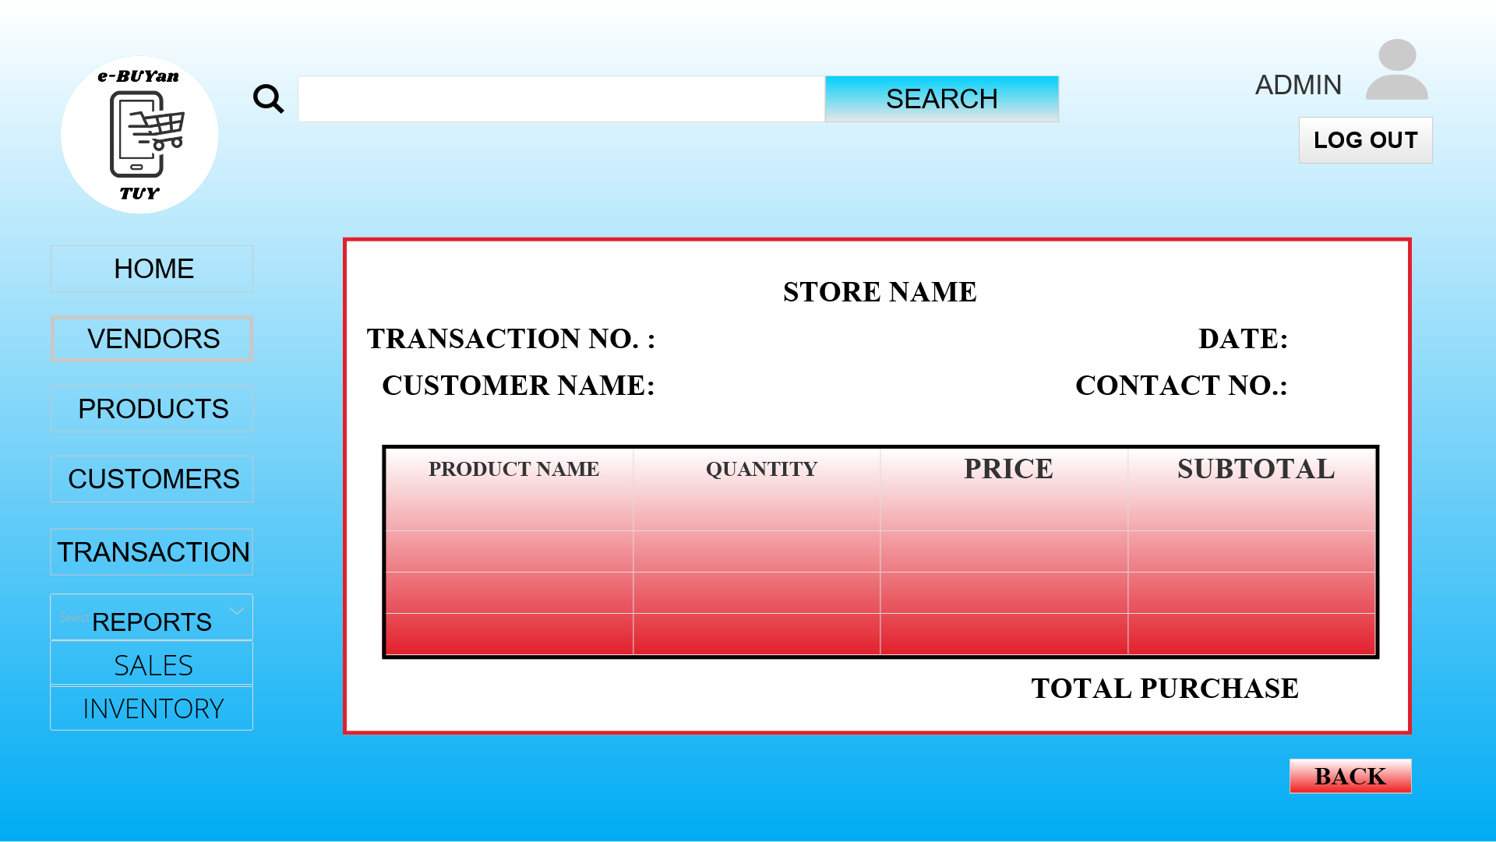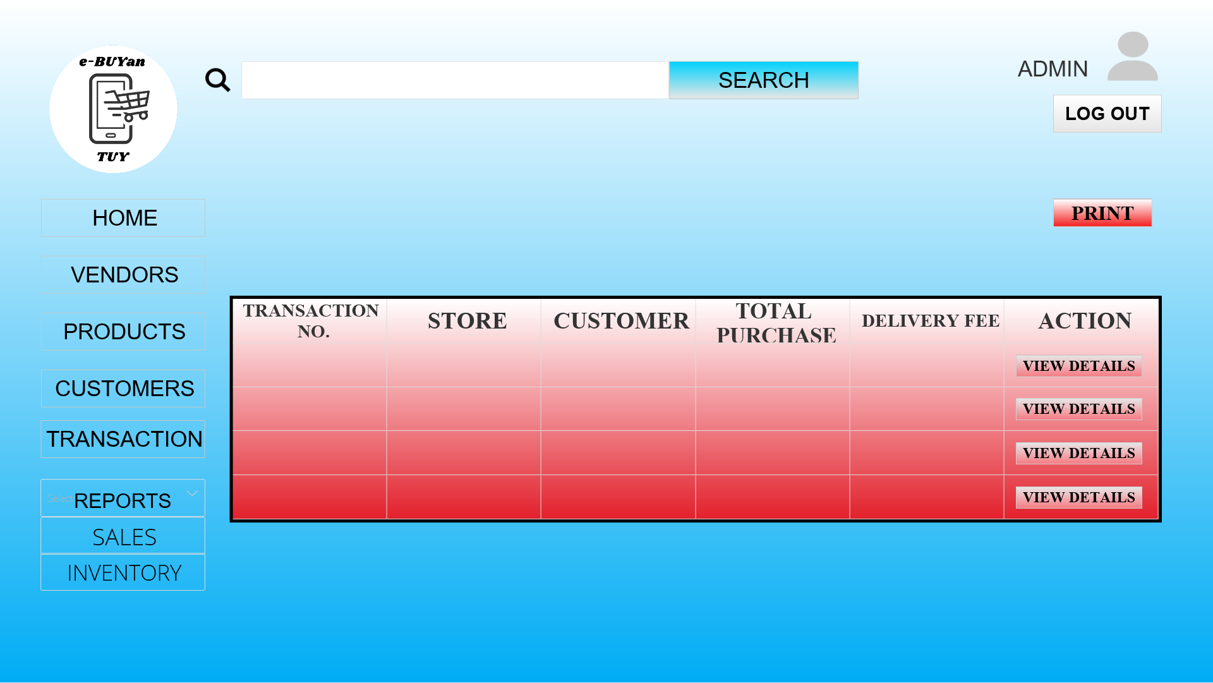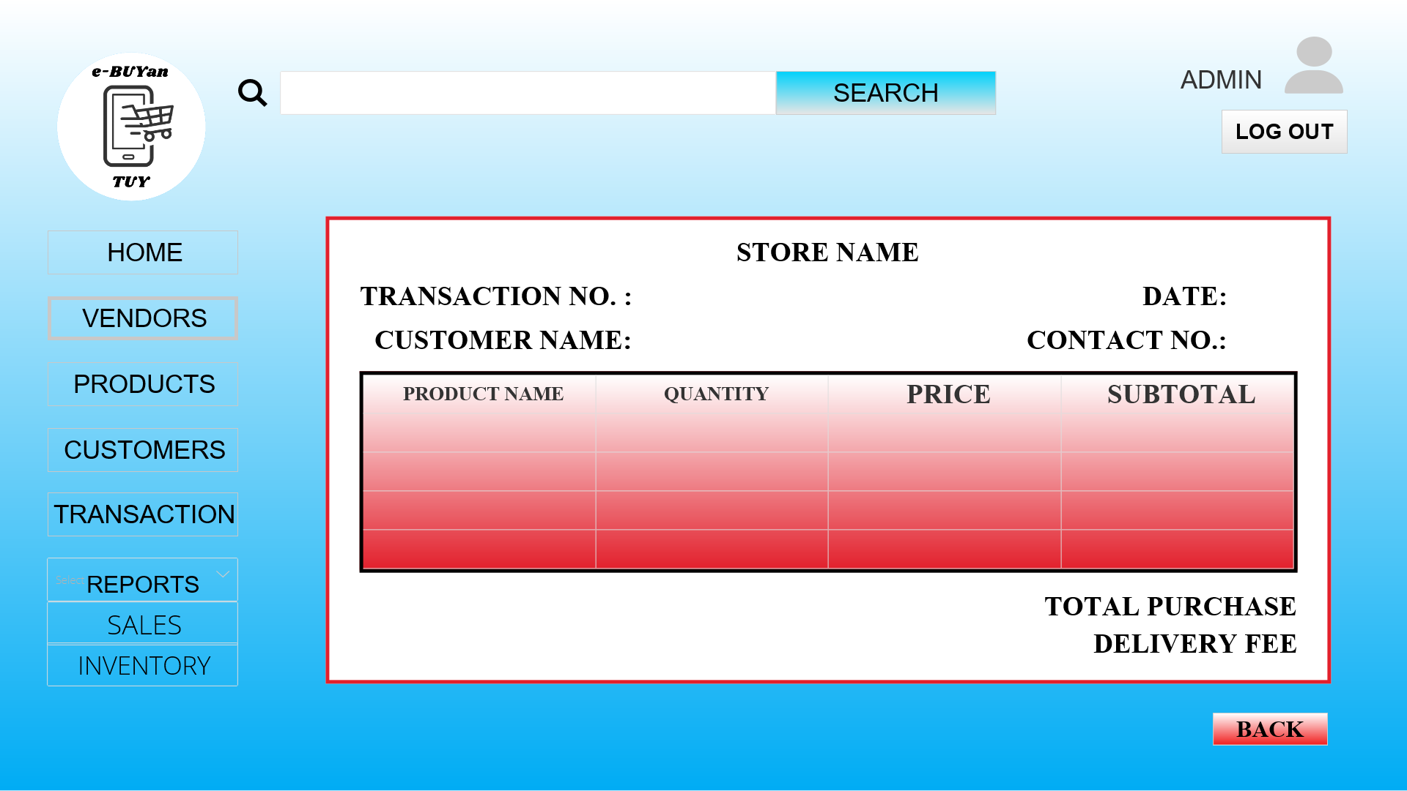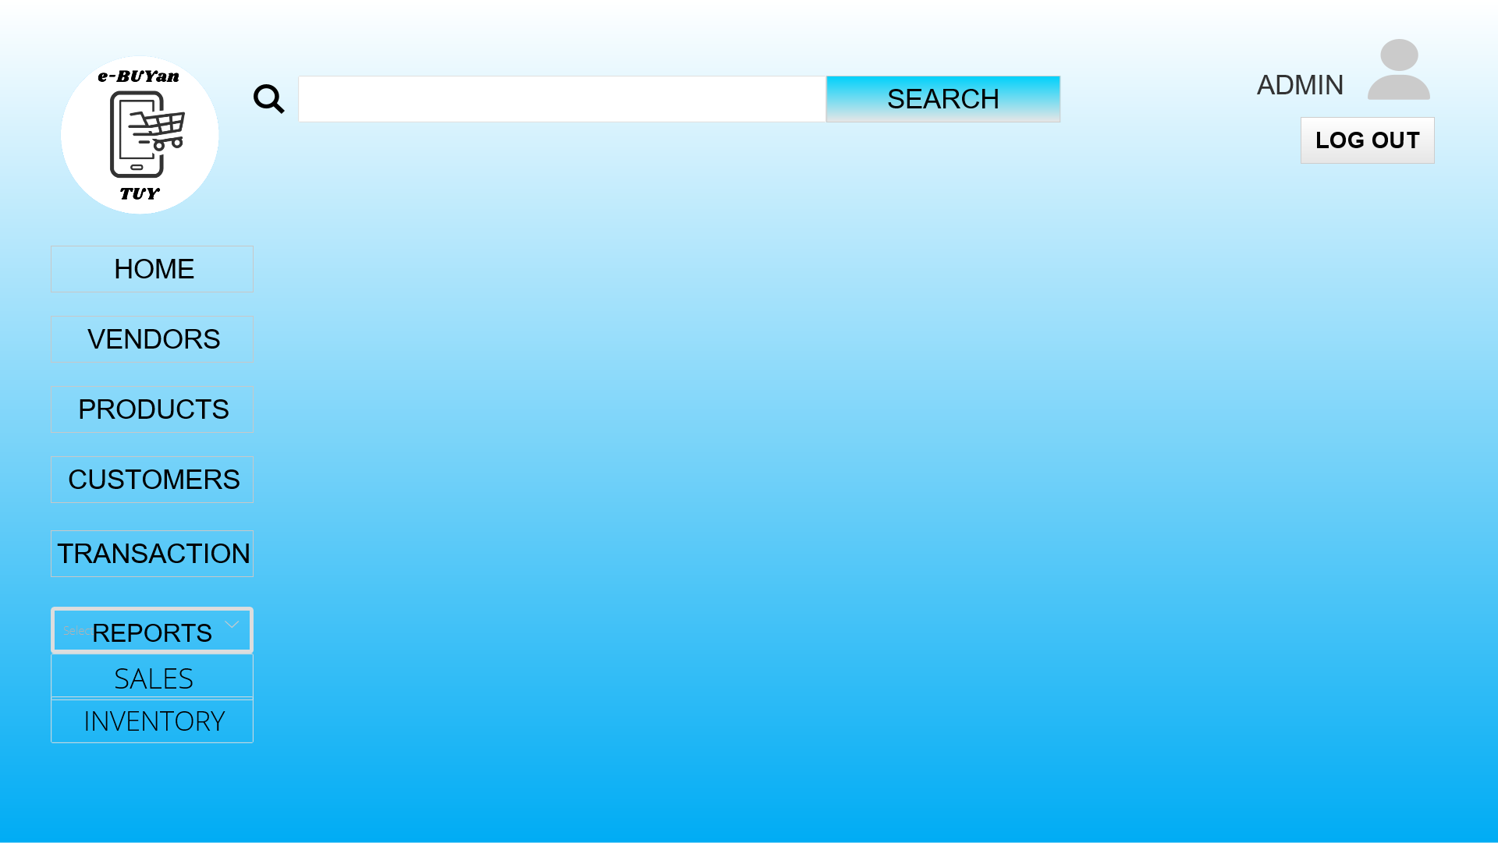

## 

## **Sales Report**

The admin has record of sales which can be printed.

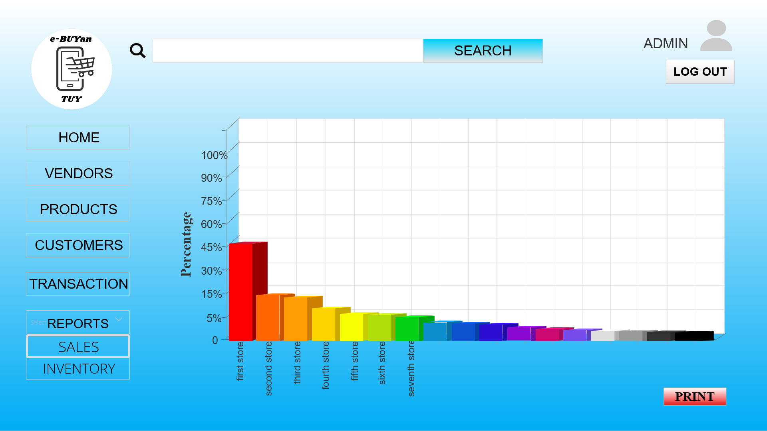

## 

## **Inventory Report**

The admin has inventory report which can be printed.

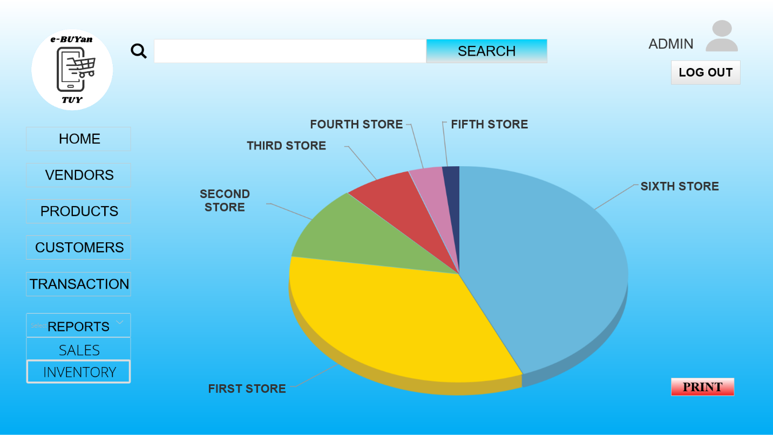

## **Vendor/Store Owner Panel**

If a Vendor/Store Owner account is identified in the log in module, it will be redirected into the Vendor/Store Owner Panel, in which a summary of accounts types can be seen and the navigation of the admin modules.

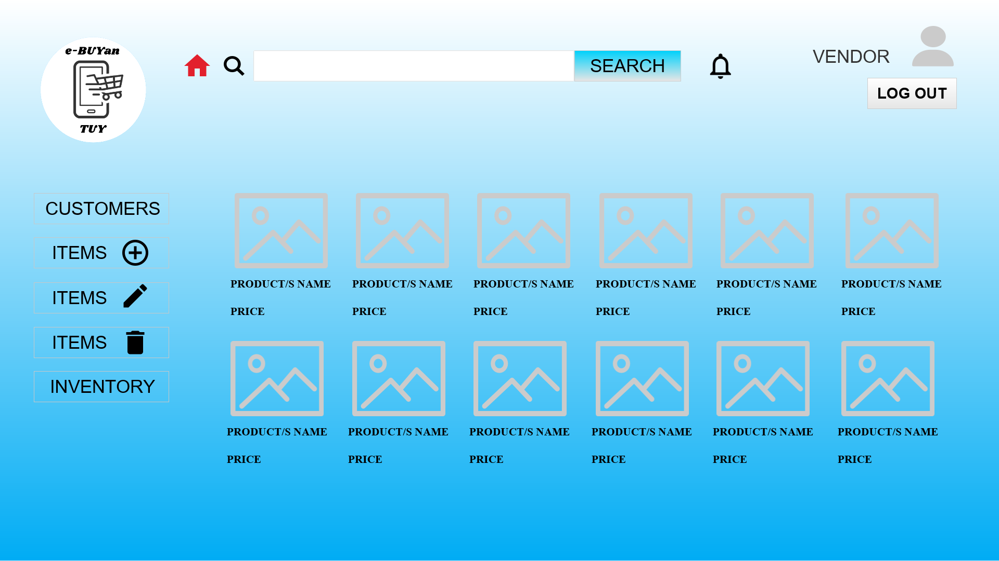

## **Vendor/Store Owner Profile**

In the Vendor/Store Owner profile. The Vendor/Store Owner can update profile credentials such as username, password and display photo.

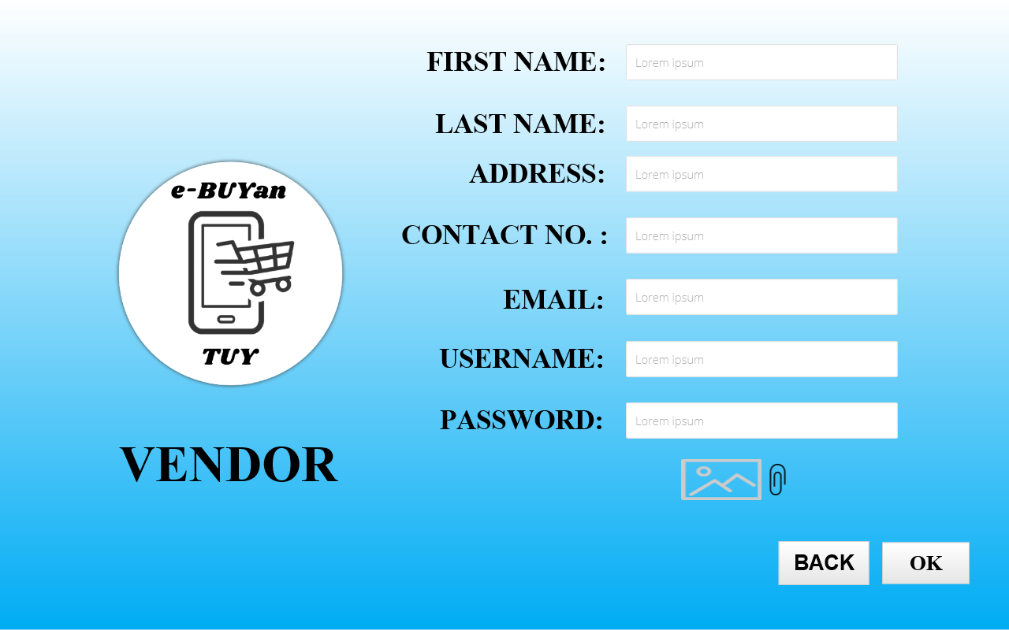

## **Vendor/Store Owner Customers**

The Vendor/Store Owner has the list of customers who ordered from the store and then the Vendor/Store Owner can approve the order made by customer.

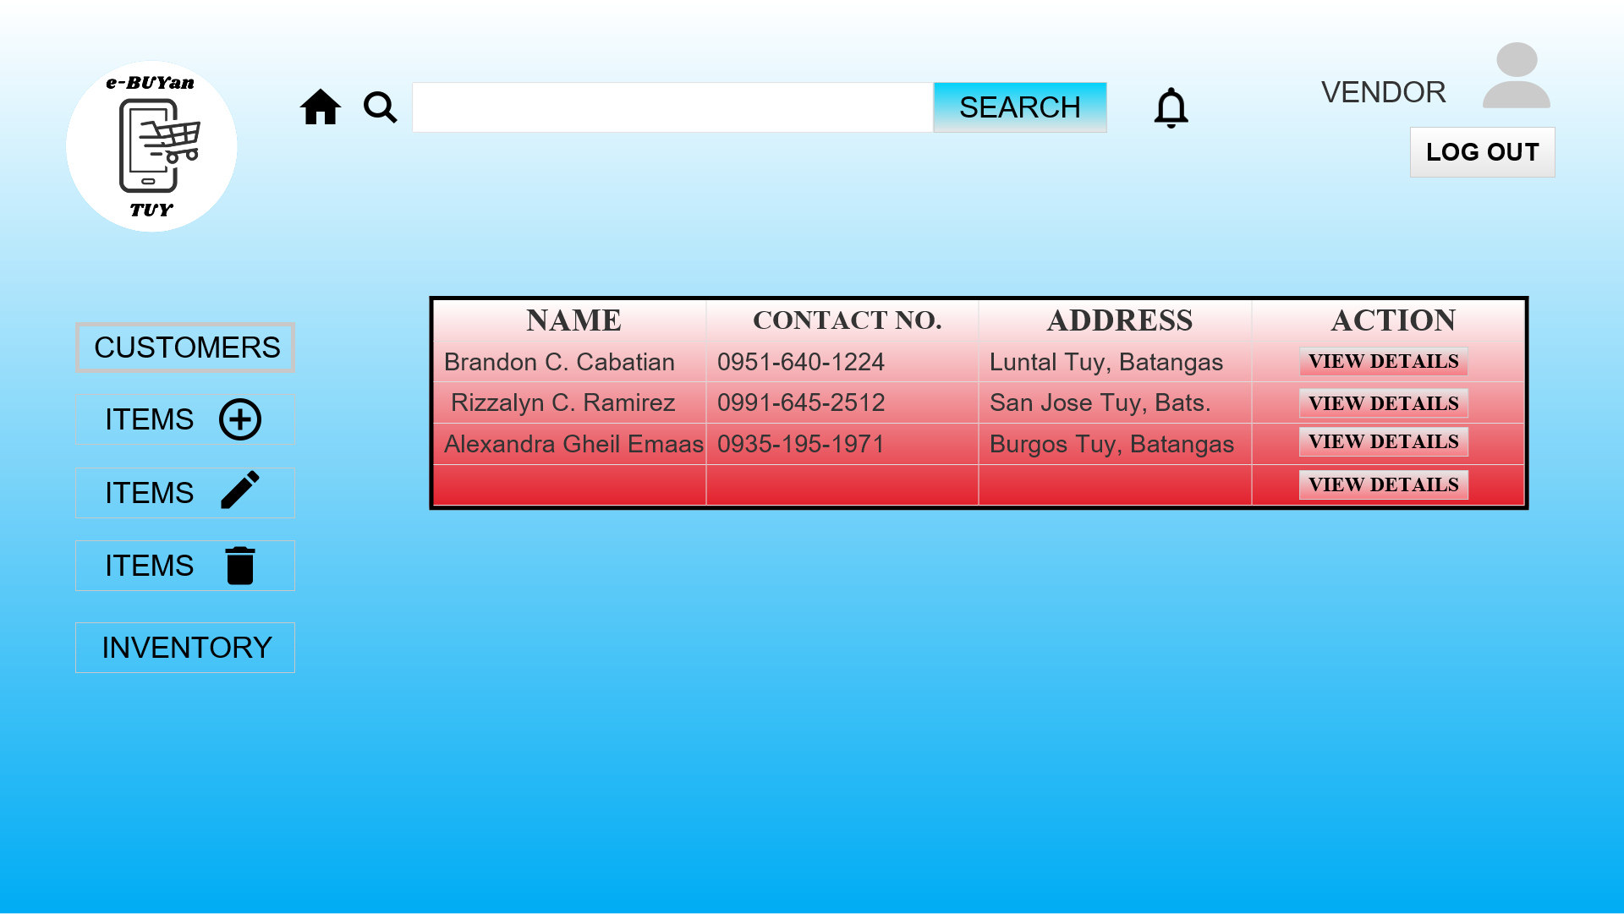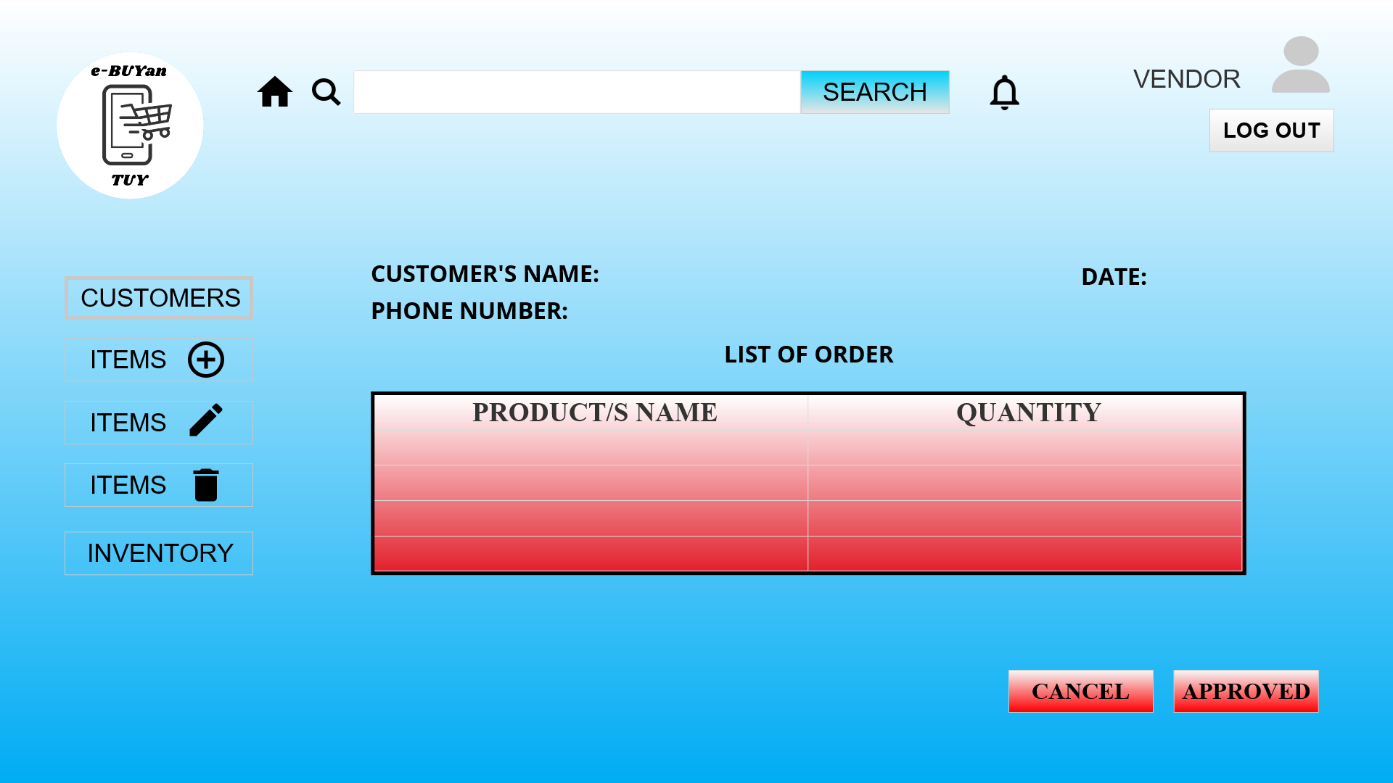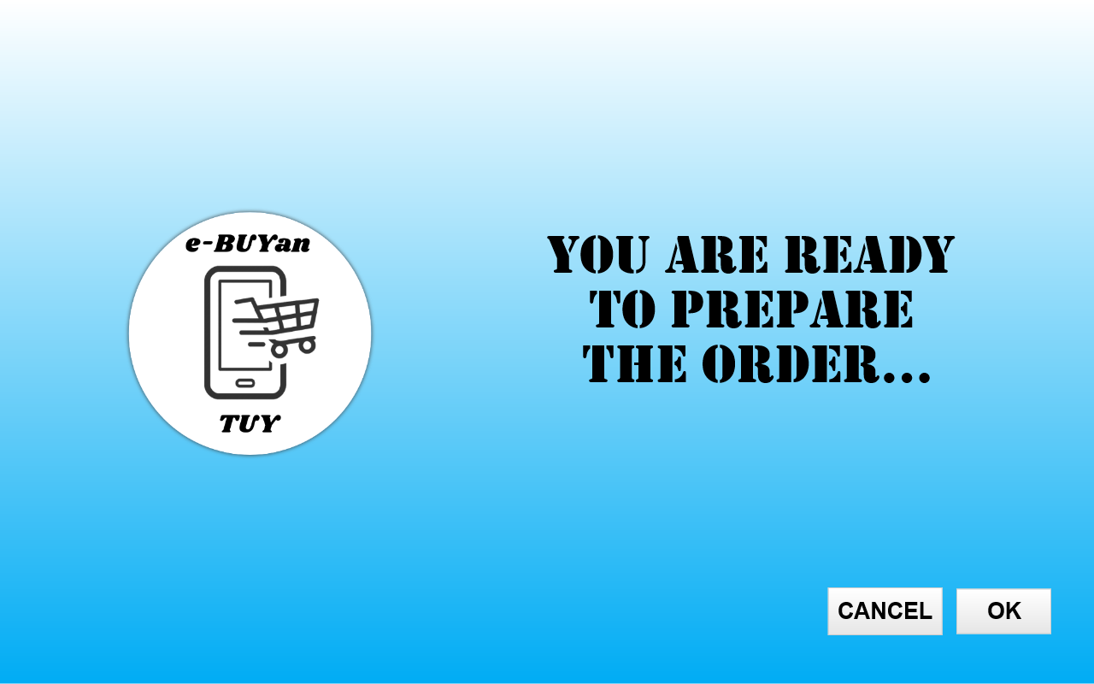

**Vendor Notification**

## The vendor can view notifications and can read, delete the notification.

## **Vendor/Store Owner Add Item/Product**

The Vendor/Store Owner can add items or products into the store that the Vendor/Store Owner manage.

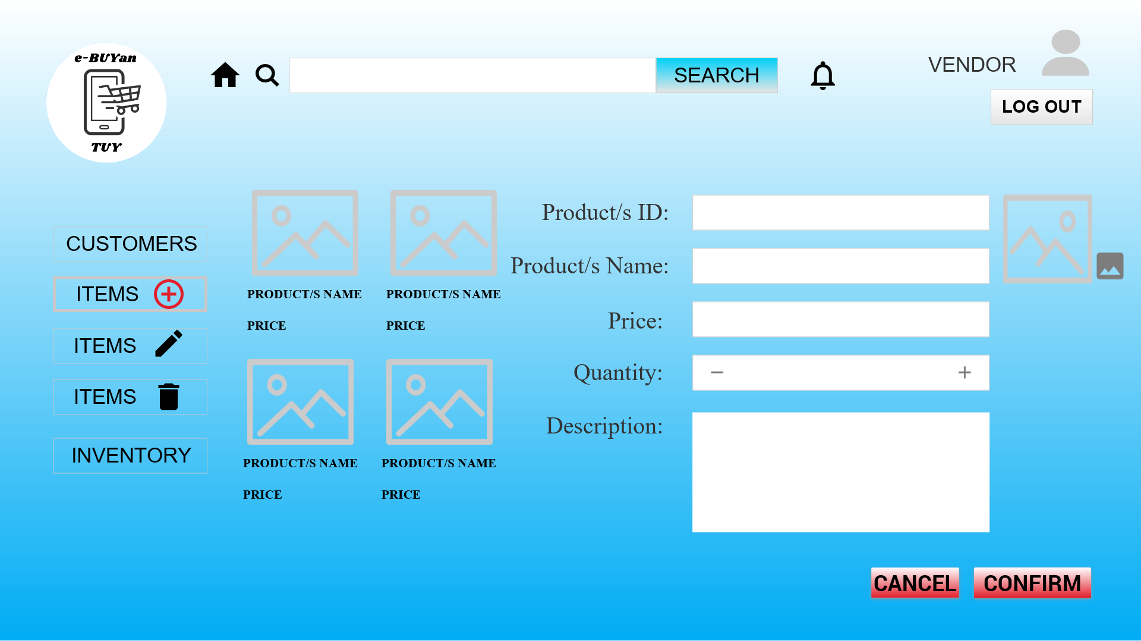

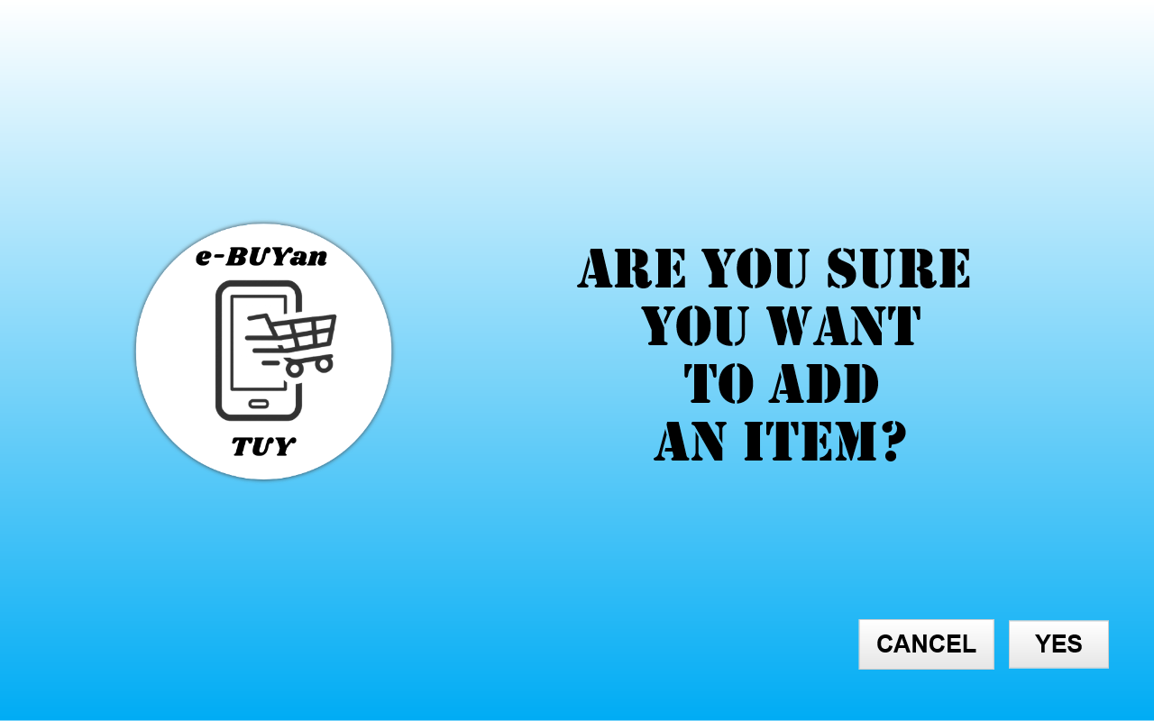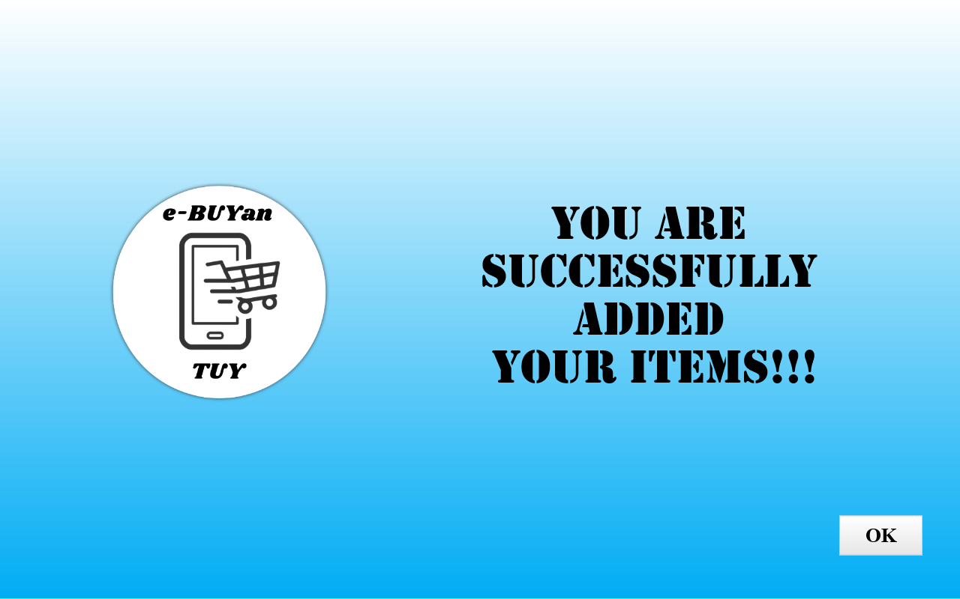

## **Vendor/Store Owner Update Item/Product**

The Vendor/Store Owner can update item’s/product’s description, quantity and price into the store that the Vendor/Store Owner manage.

## 

## **Vendor/Store Owner Delete Item/Product**

The Vendor/Store Owner can delete items or products into the store that the Vendor/Store Owner manage.

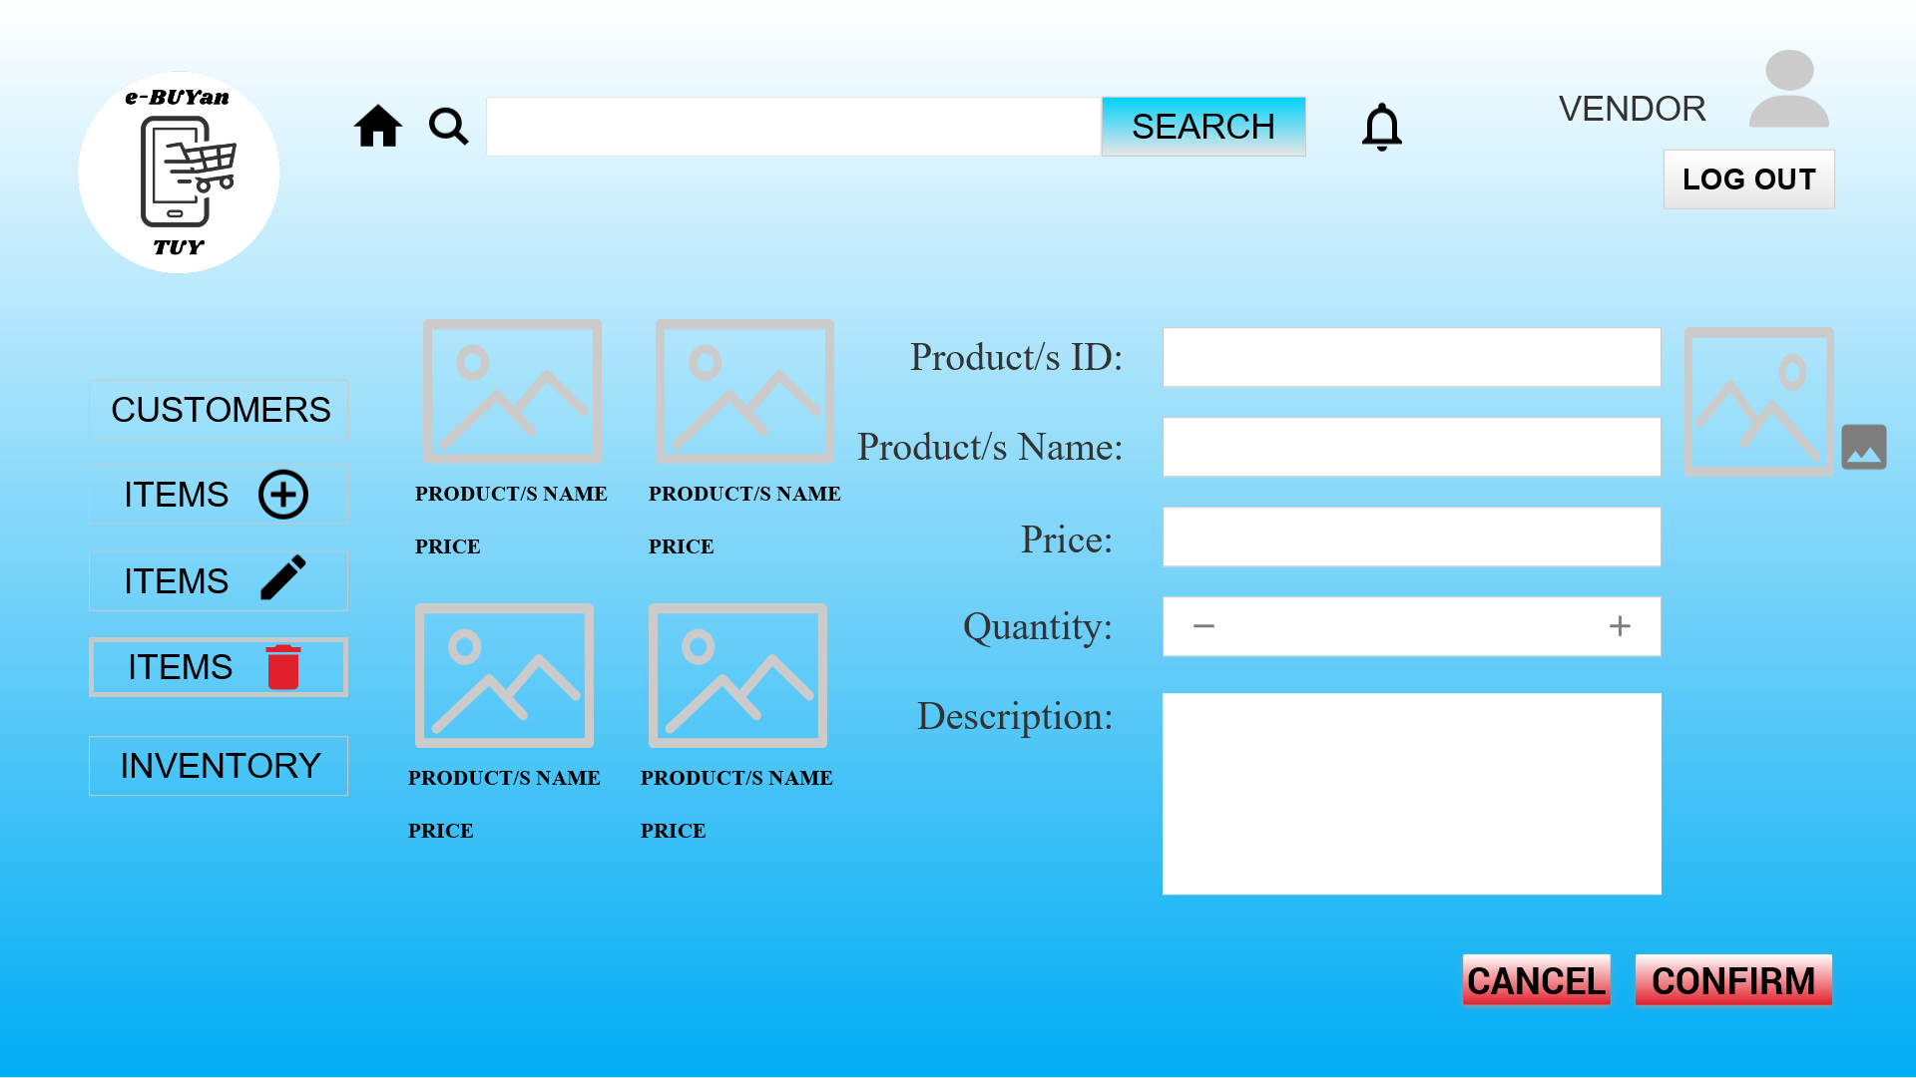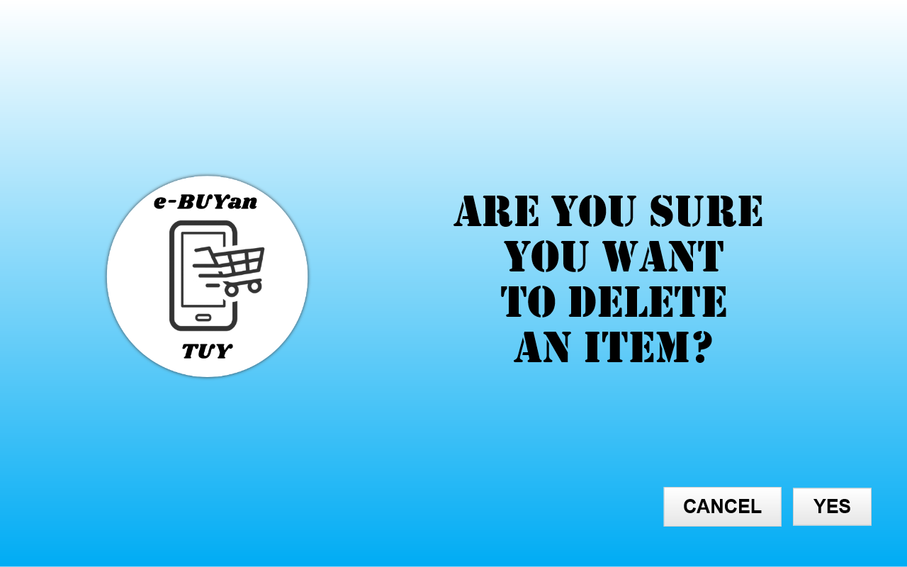

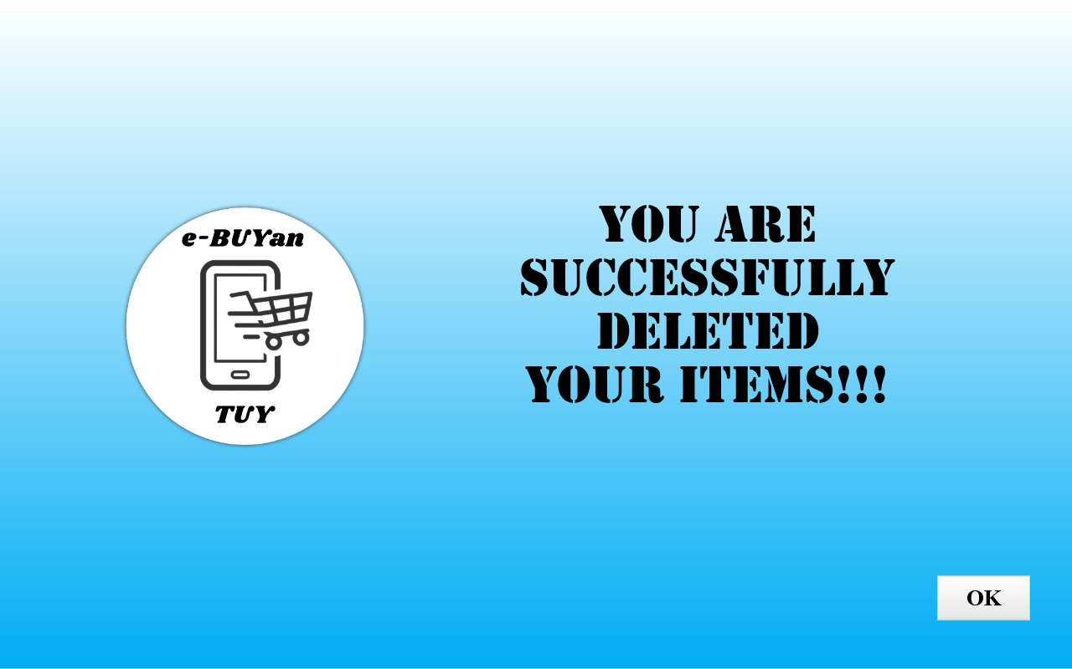

## 

## **Vendor/Store Owner Inventory**

The Vendor/Store Owner can view all the items/products in the store that the owner handles. 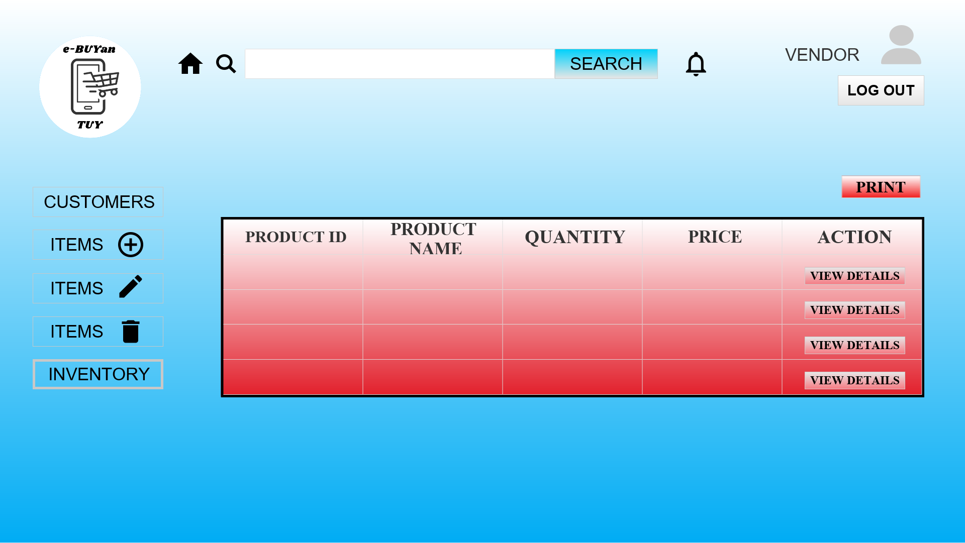

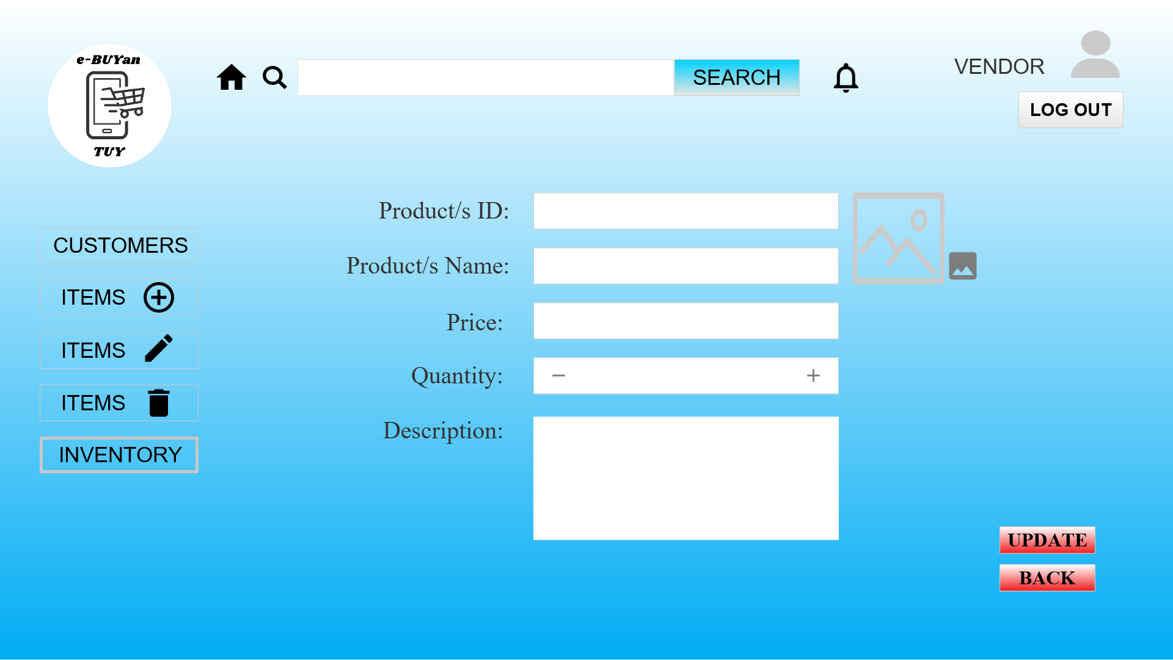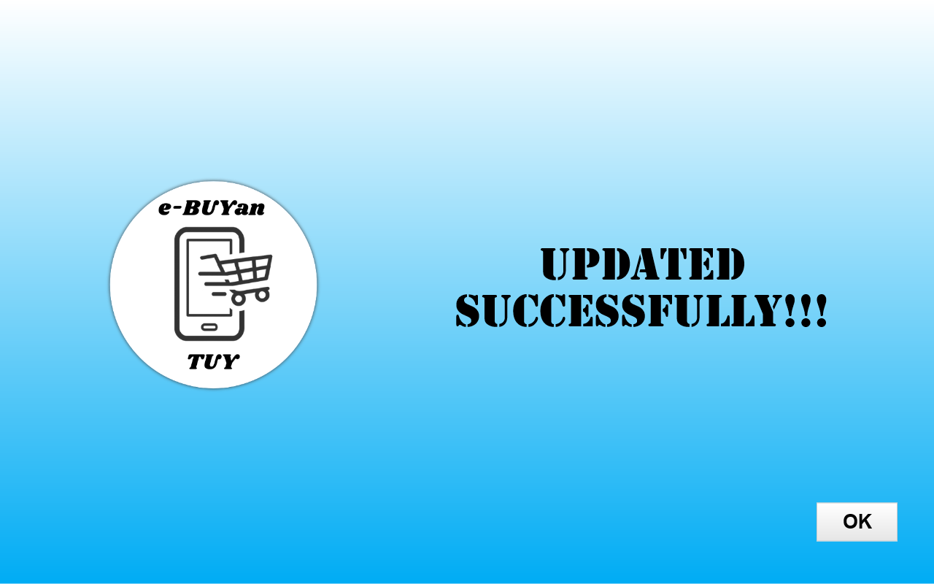

## 

## **Customer Panel**

If a Customer account is identified in the log in module, it will be redirected into the Customer Panel, in which a summary of accounts types can be seen and the navigation of the admin modules.

## 

## **Customer Profile**

In the Customer profile. Customer can update account profile credentials such as username, password and display photo.

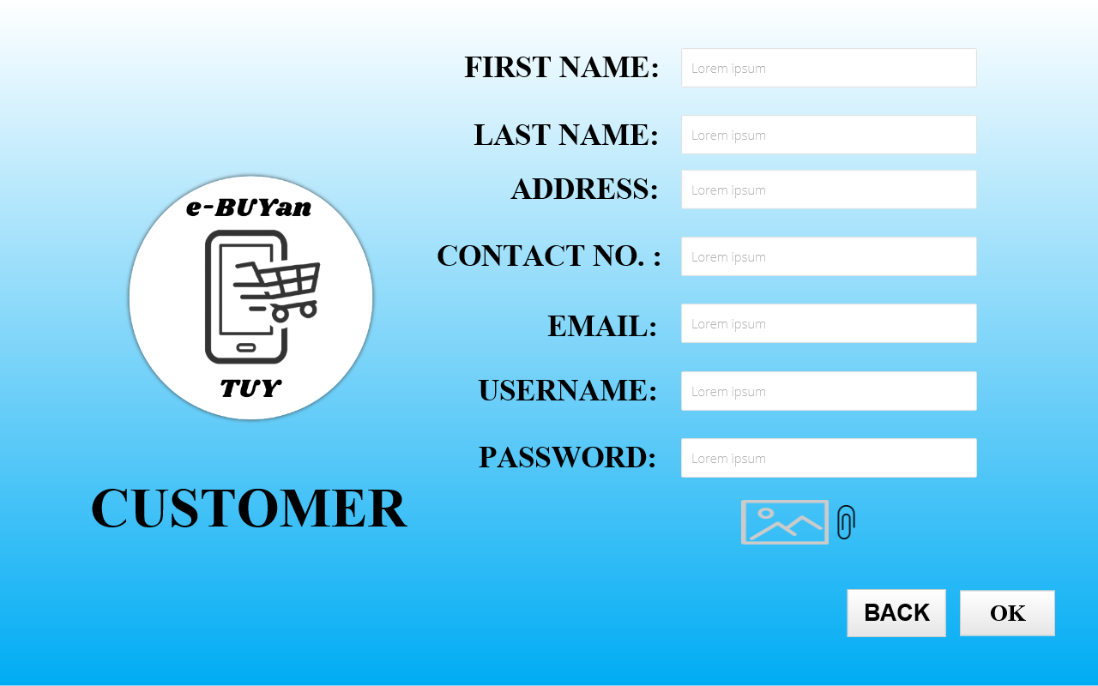

## **View Store**

The Customer can select categories of stores. After selecting, the customer can view stores and choose items that will be added to cart.

## 

**View Items**

The customer can view the details of the product. 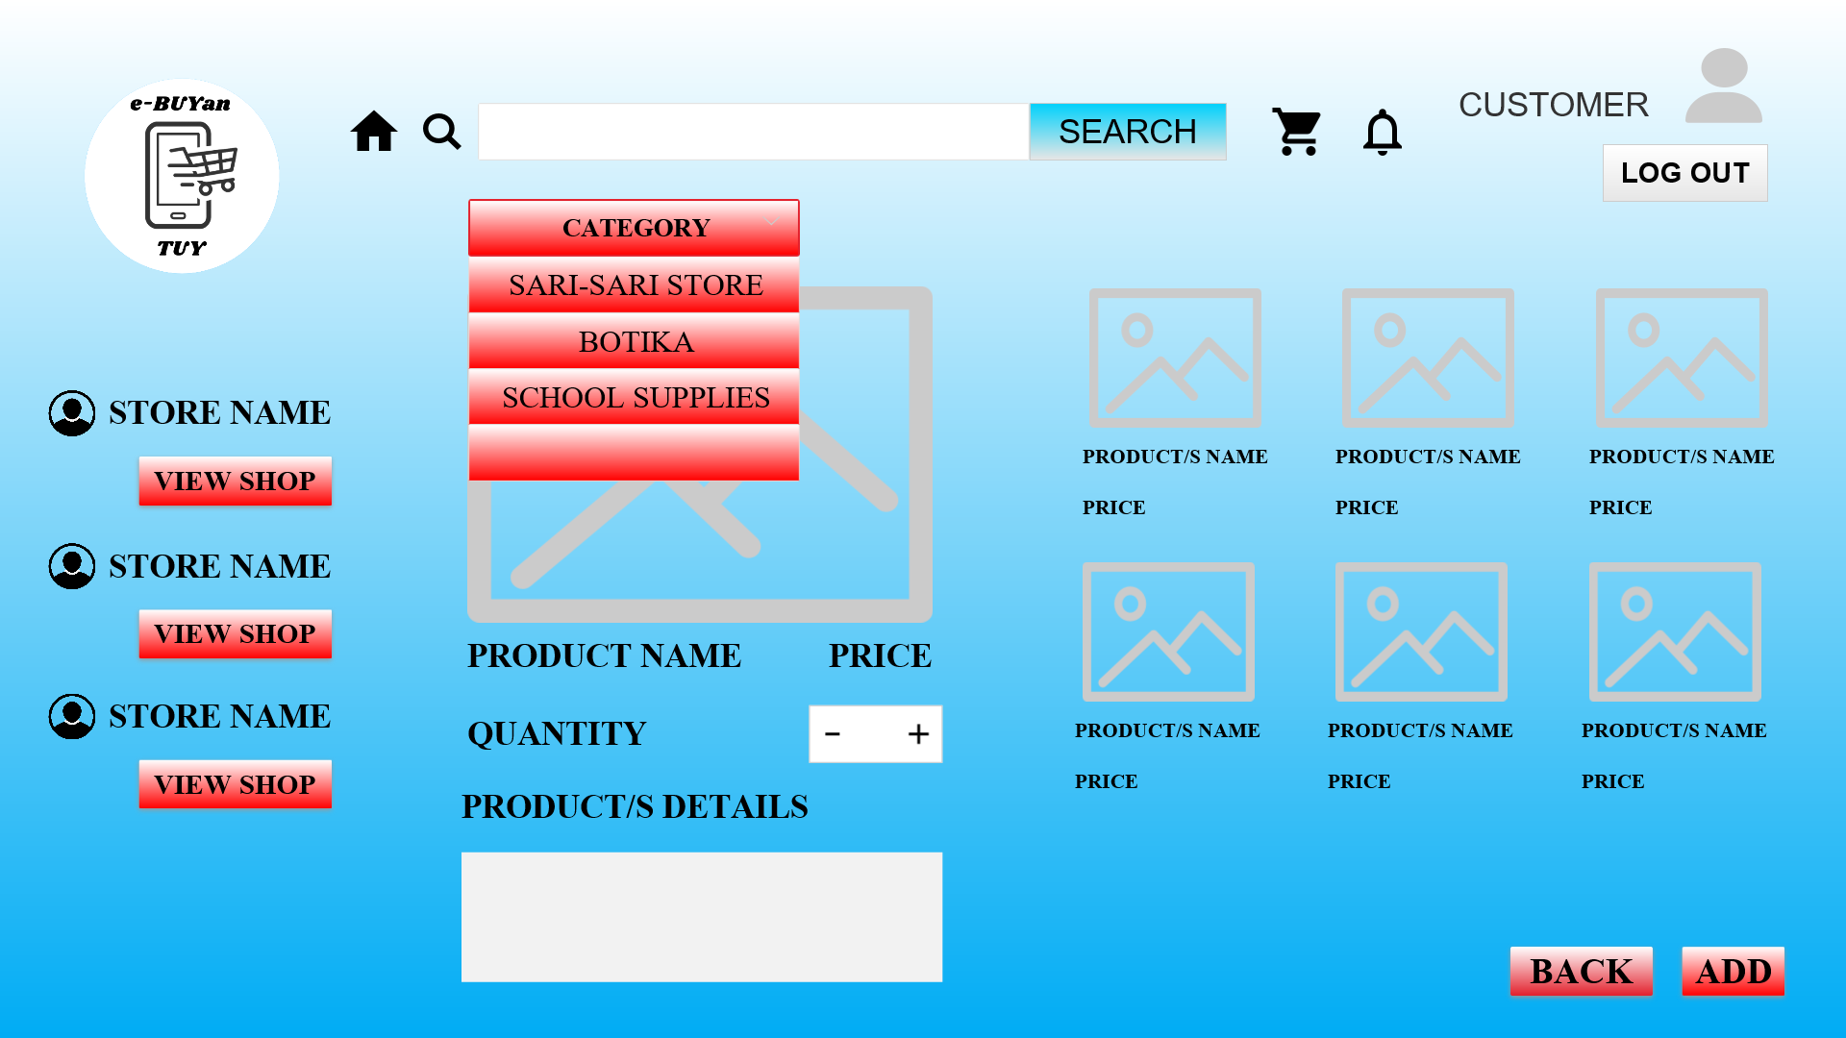

## 

## **Cart**

The items/products that the customer added will be displayed to the cart. The customer can update the quantity of added items/products and can delete the whole order as well as placing the order

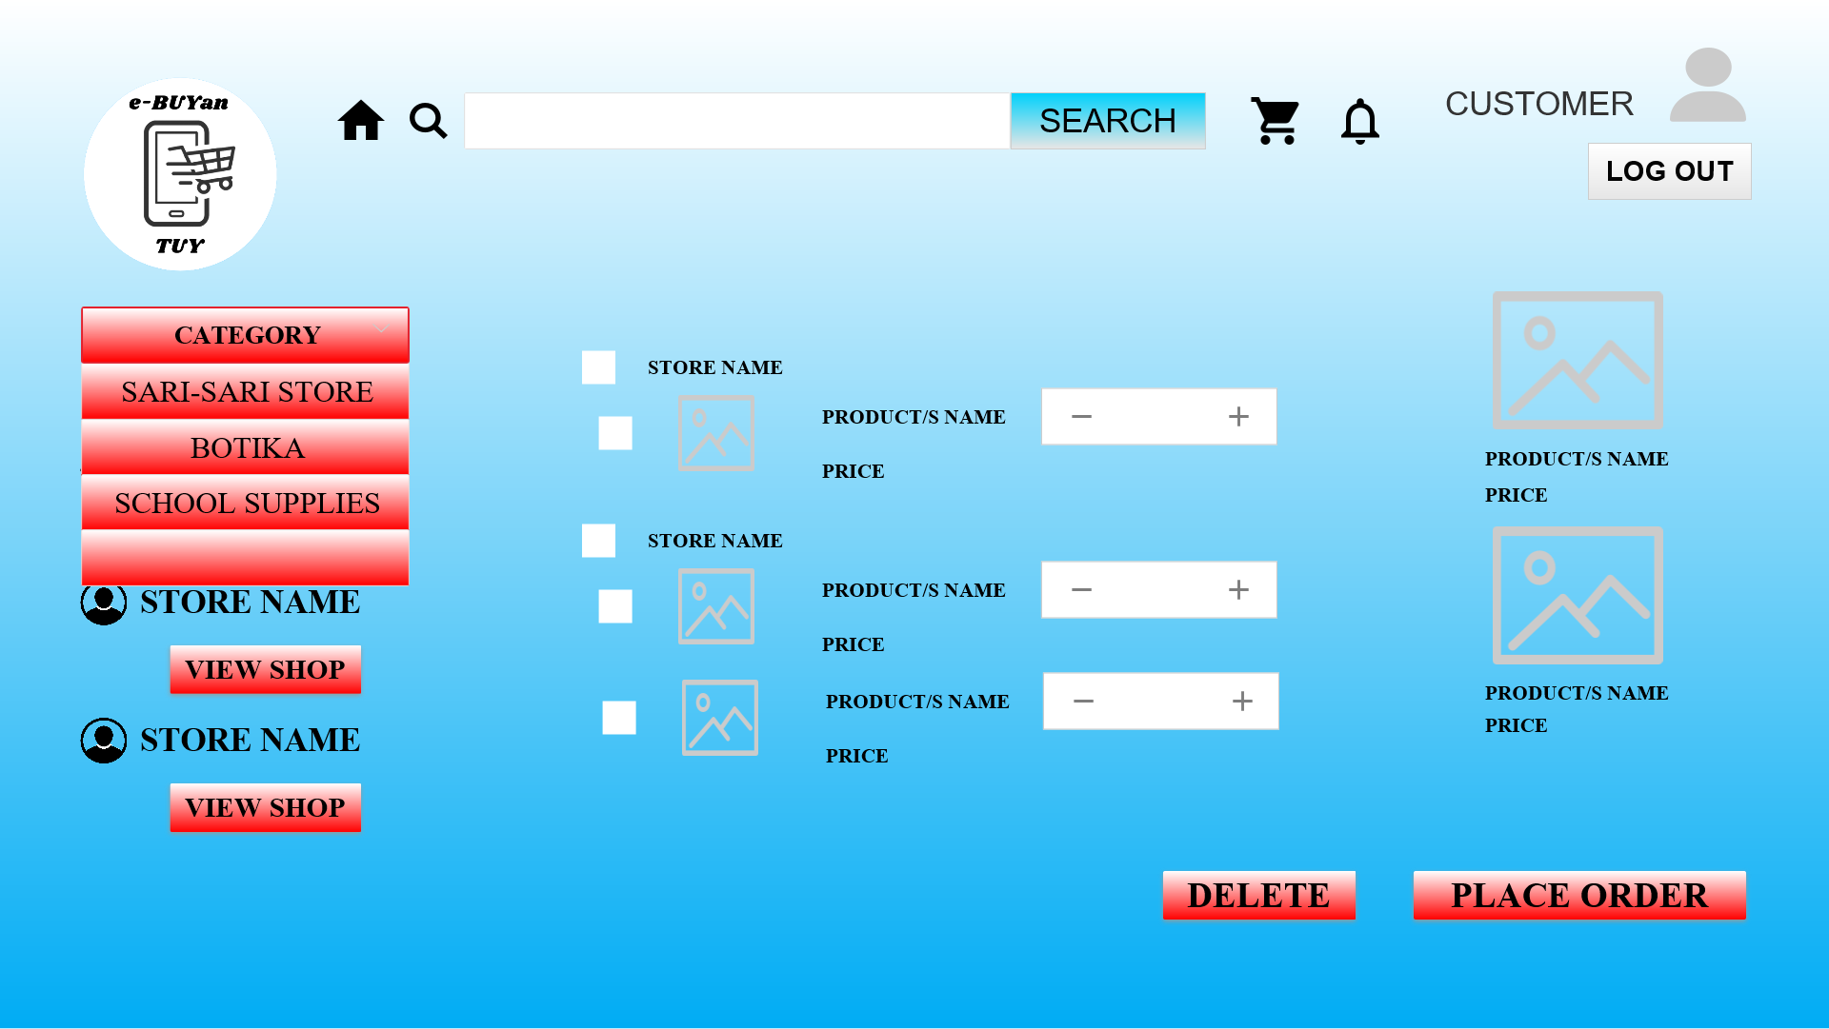

.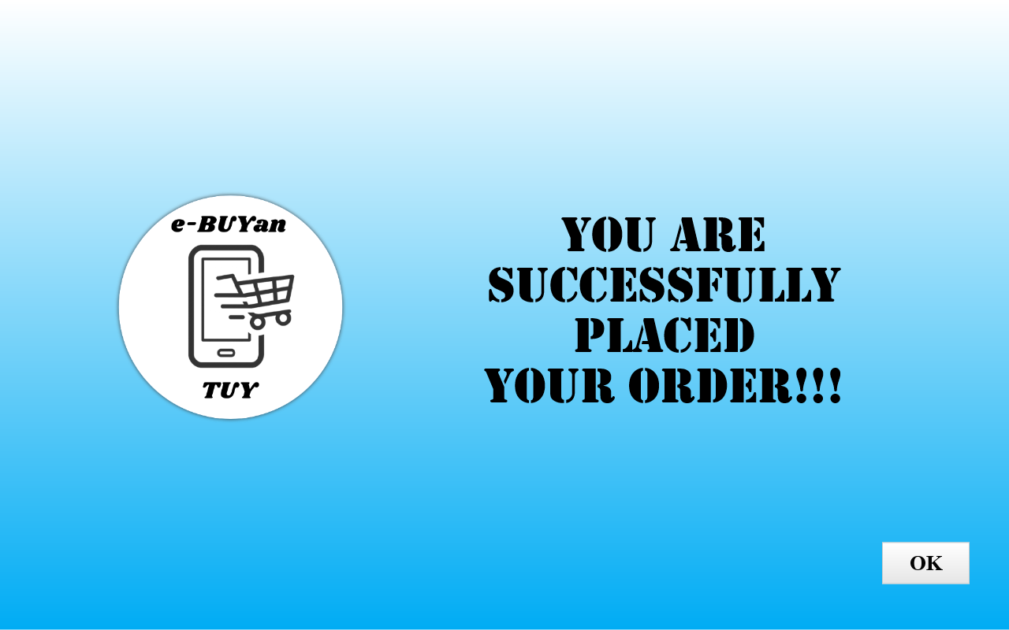

## **Customer Notification**

The customer can view notifications and can read, delete the notification.

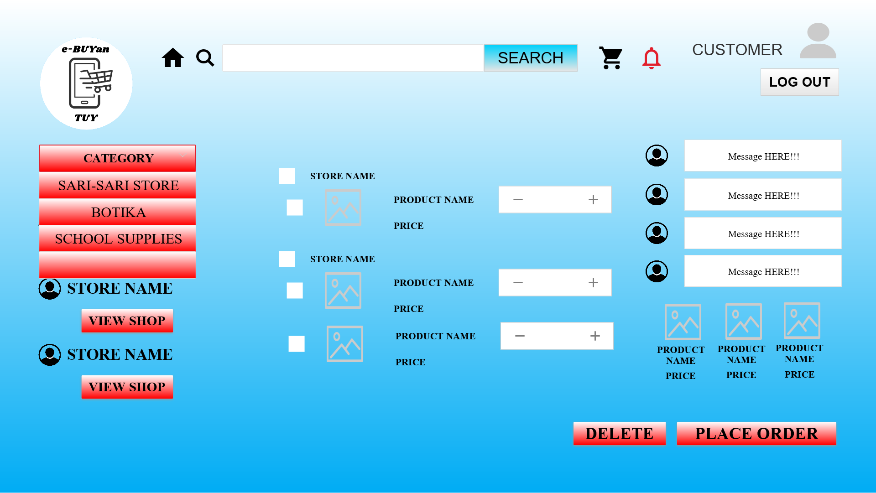

## 

## **Driver Panel**

If a Driver account is identified in the log in module, it will be redirected into the Driver Panel, in which a summary of accounts types can be seen and the navigation of the admin modules.

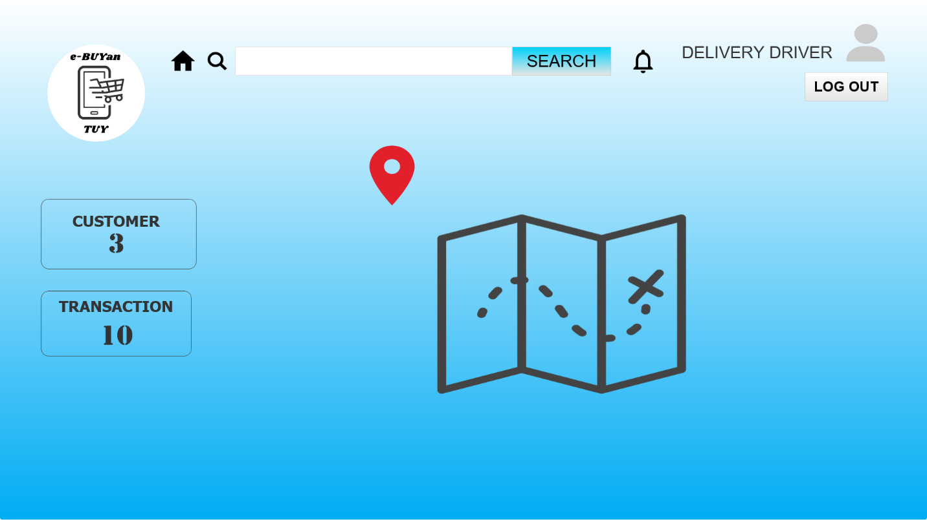

## 

## **Driver Profile**

In the Driver profile. The Driver can update profile credentials such as username, password and display photo.

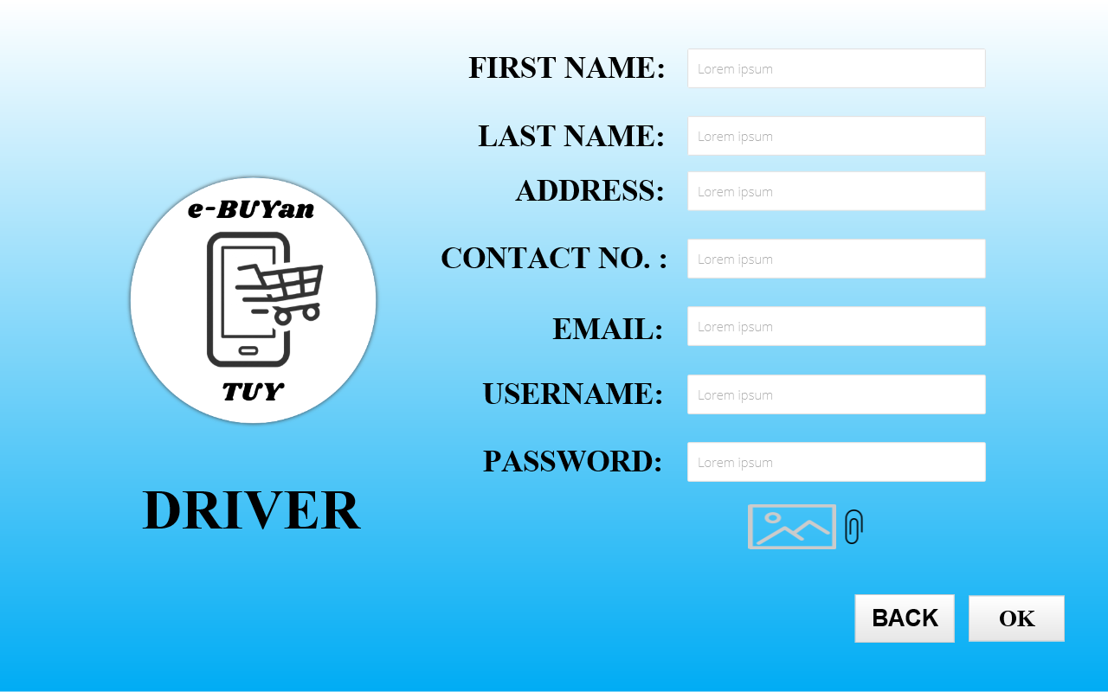

## **Driver Notification**

The driver has notification module in which it shows the messages such as customer order details, transaction and others 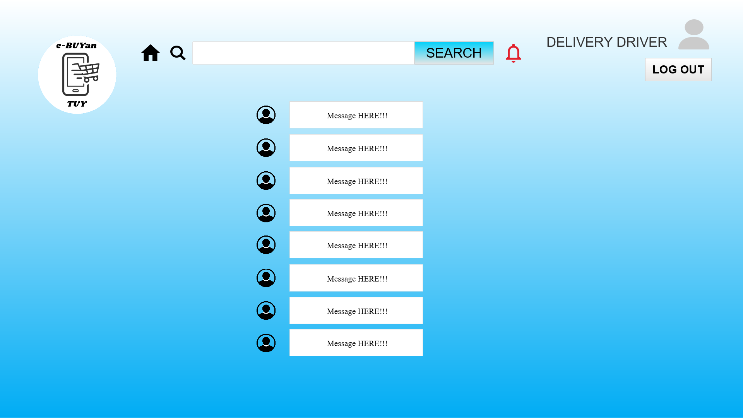

## **Driver Customer**

The driver can view the list of customers with the order details that the driver will buy and the location in which the driver will deliver.

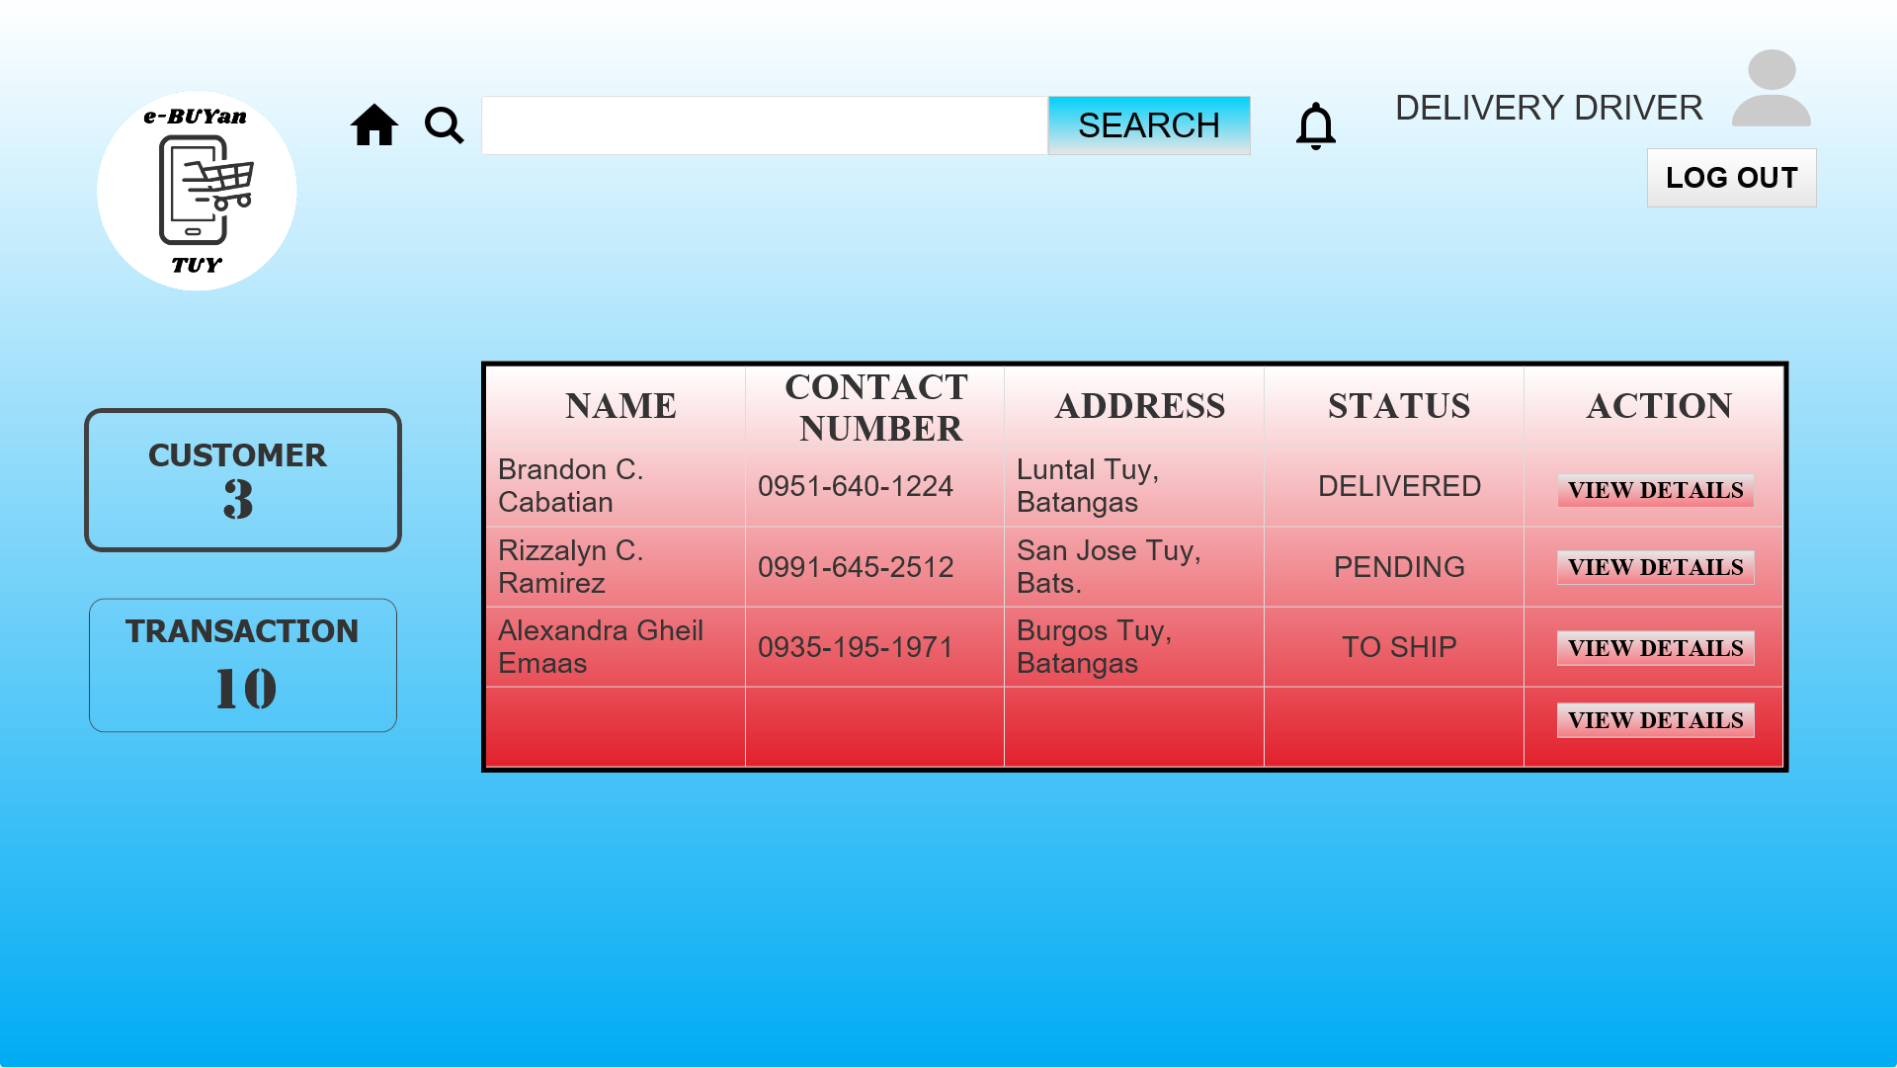

## 

## 

## **Driver Transactions**

The drivers have the records of the transactions made.

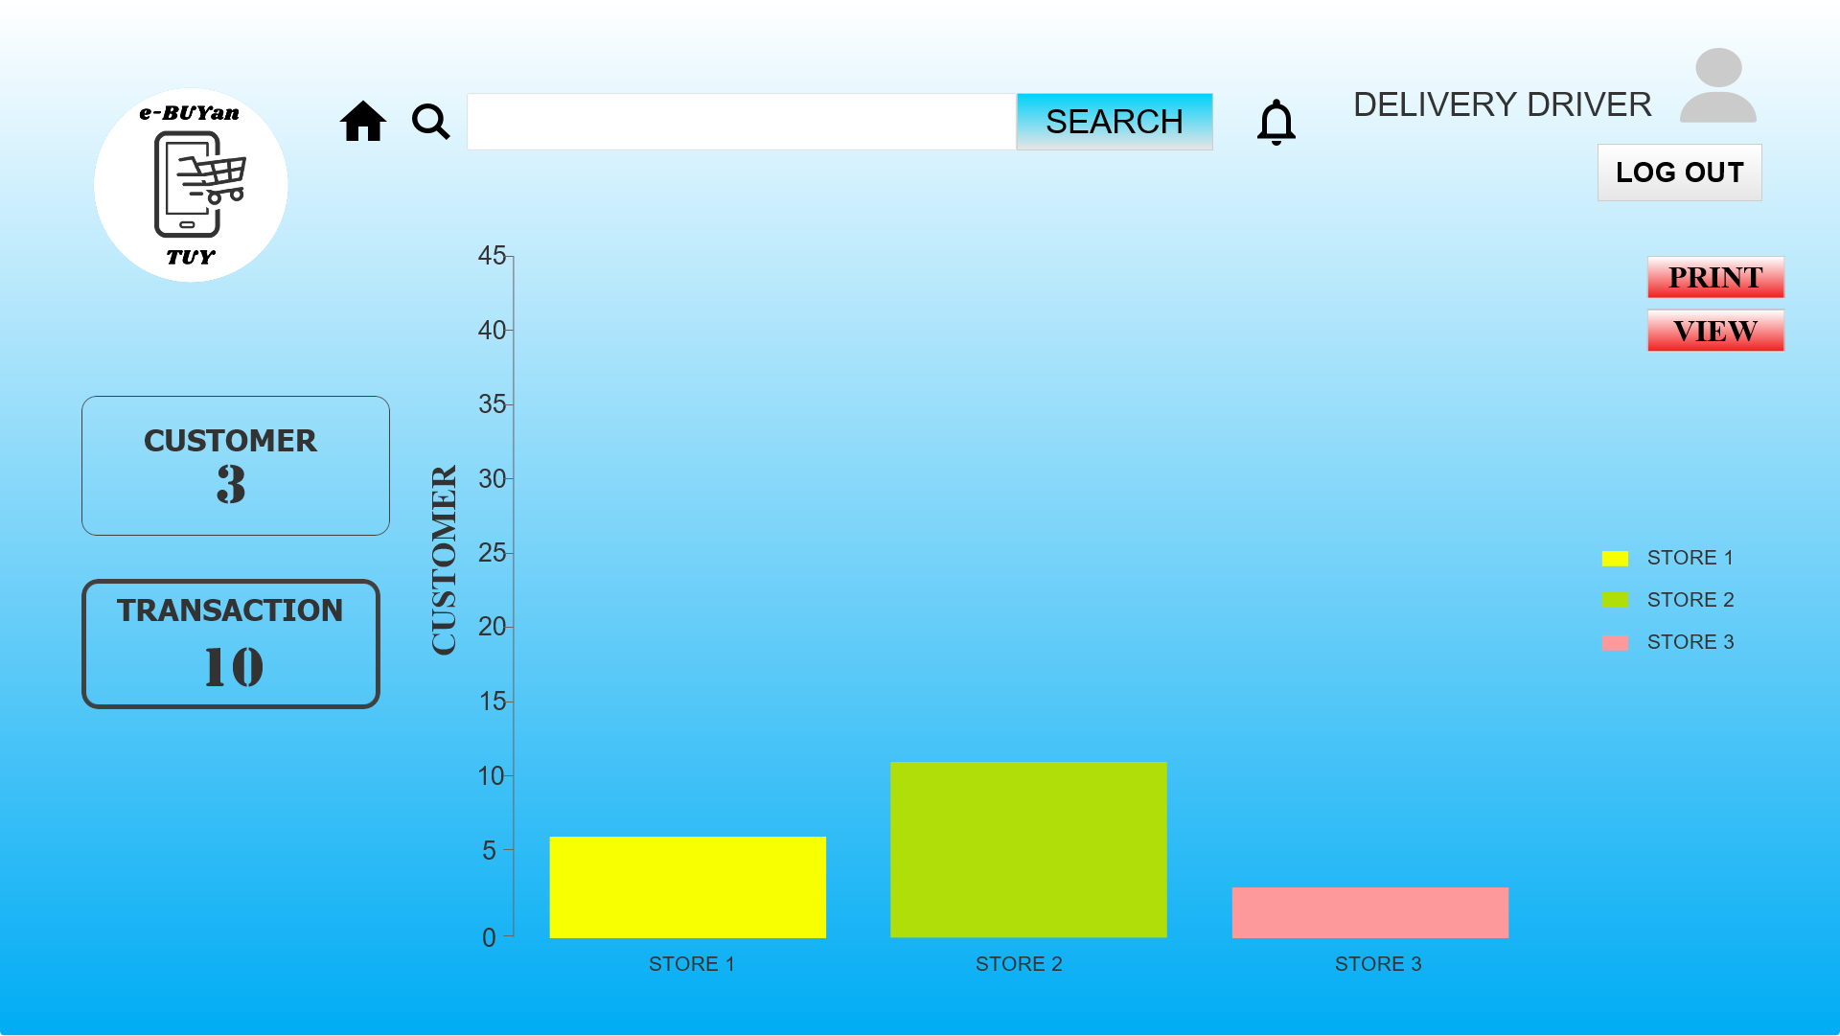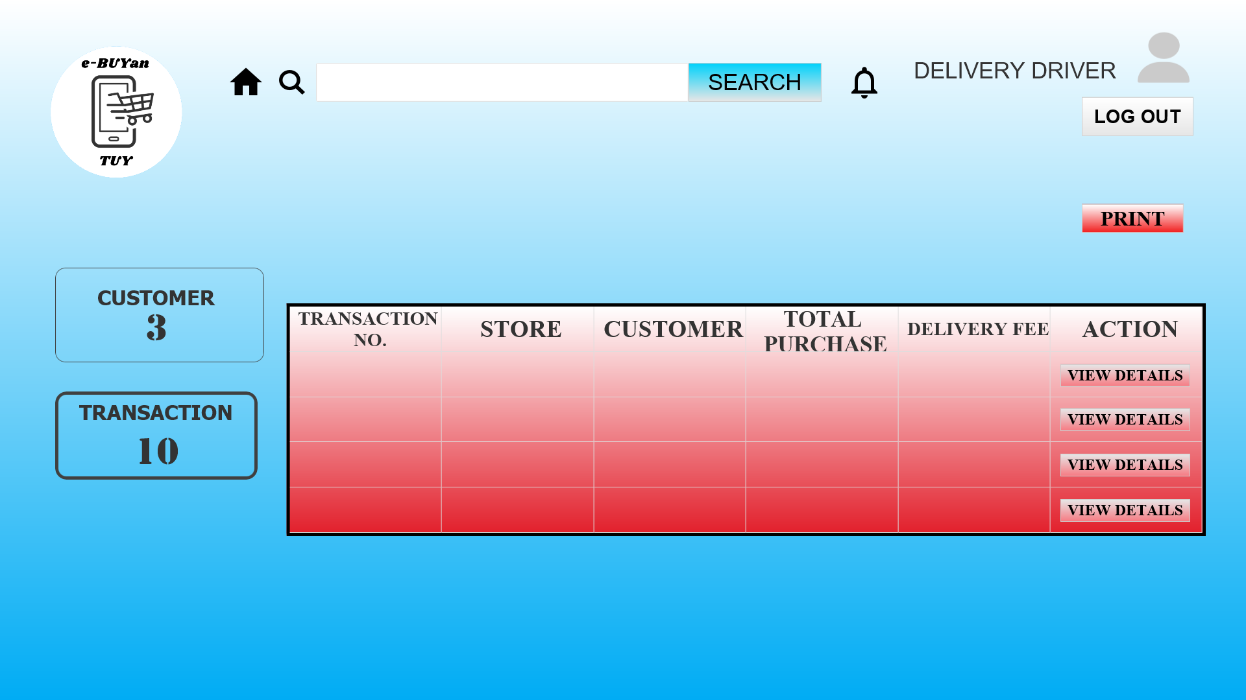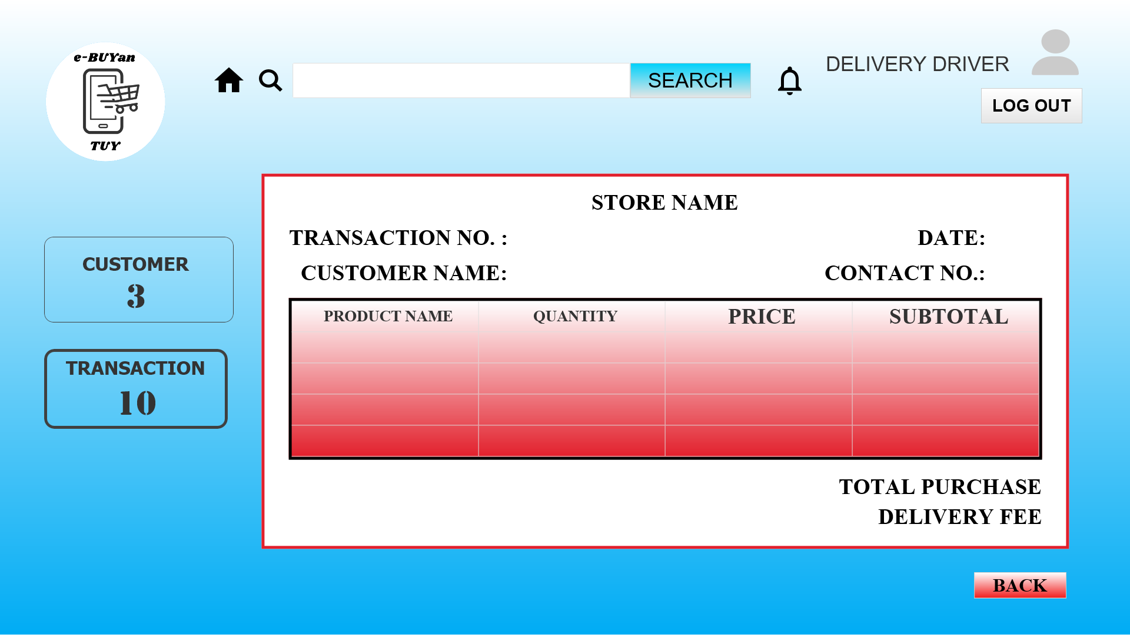

## **User Log Out**

After all the task that the user performed. The user now can log out that will terminate the processes of the system.

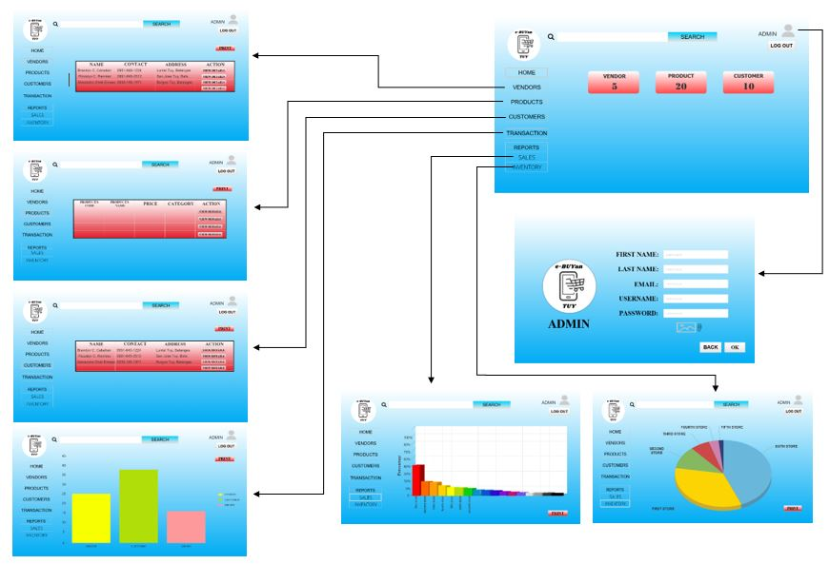**MAP WORKFLOW**

**ADMIN**

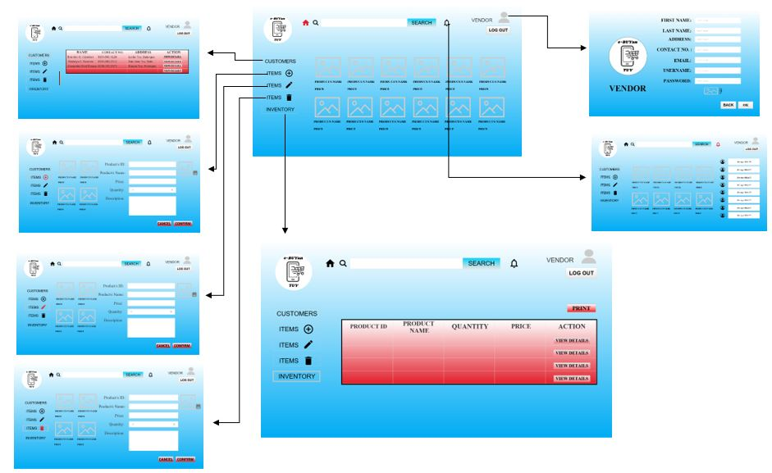

**VENDOR**

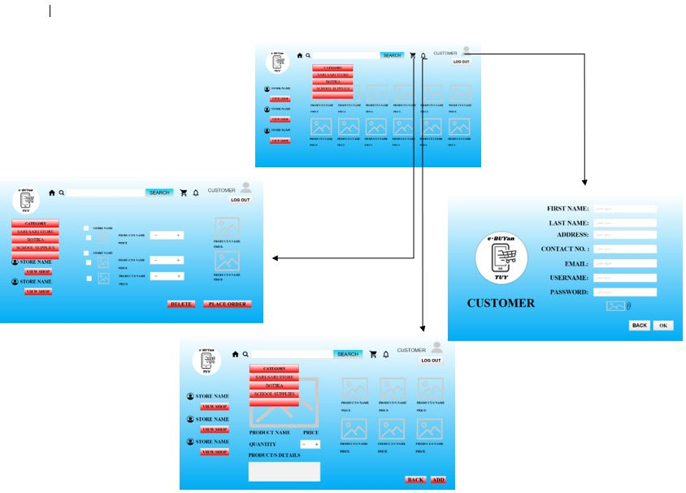

**CUSTOMER**

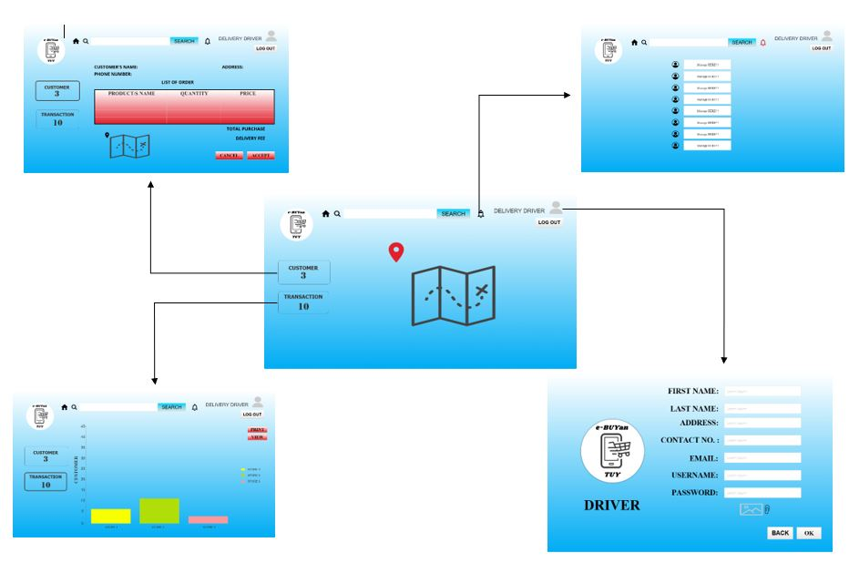

**DELIVERY DRIVER**